# 

*ME-419: Production Management*

Final report – Sony Headphones WH-1000XM5

*Team members: Yong-Qi Gao, Berta Leach, Ivan Ushakov, Huiyun Zhu*

*TA Mentor: Xavier Groux*

Table of Contents

**Executive Summary 3**

**1. Introduction and Company information 3**

**1.1 Company History and Background** 3

**1.2 Products, Product Families, and Services** 3

**1.3 Production Sites, Suppliers, Markets, Warehouses, and Hubs** 4

**1.4 Vertical Integration Level of Supply Chain** 5

**1.5 Company’s Primary Competitors** 5

**1.6 Current and Future Challenges** 5

**2. Positioning of Sony and SONY WH-1000XM5 6**

**2.1 Elements of Value** 6

**2.2 Product in Sony’s Ecosystem** 6

**3. Characteristics of SONY WH-1000XM5 7**

**3.1 Value Adding Network (VAN)** **[3][8]** 7

**3.2 Material and Information Flows** 7

**3.3 Hierarchical Description of the Bill of Material (BoM)** 8

**4. Demand Forecast & Planning 9**

**4.1 Introduction** 9

**4.2 Goal of Forecasting and Assumptions** 9

**4.3 Data Analysis** 9

**4.3.1 Data Cleaning** 9

**4.3.2 Data Aggregation** 10

**4.3.3 Seasonality and Trend detection** 11

**4.3.4 Preliminary forecast model** 12

**5. Production Planning 18**

**5.1 Introduction** 18

**5.2 Aggregate Plan** 18

**5.2.1 Initial conditions** 19

**5.2.2 Cost analysis** 19

**5.2.3 Aggregated Plan strategy selection** 19

**5.3 Master Production Schedule (MPS)** 21

**5.3.1 Authorised MPS** 22

**5.3.2 RCCP** 23

**5.4 Material Requirement Planning (MRP)** 23

**5.5 Economic Ordering / Production Quantity** 24

**5.5.1 EOQ** 24

**5.5.2 EPQ** 25

**5.6 Discount Model** 26

**5.7 Inventory Management Models** 26

**5.7.1 Safety stock model** 26

**5.7.2 Periodic review model** 27

**5.7.3 Single Period inventory model (also known as Christmas model)** 29

**6. Conclusions 29**

**7. References 30**

**8. Disclosure of AI Tool Usage 31**

## **Executive Summary**

Sony positions itself as a leader in technological innovation, premium product quality, and superior user experience. They aim to create value through enriching emotional experiences, realizing the dreams of creators, and contributing to society’s safety, health, and reliability. The company has a diverse portfolio including Electronics Products & Solutions, Game & Network Services, Financial Services, Pictures, Imaging, and Music. In the modern-day competitive market, this places Sony in a strong position relative to its competition: Apple, LG, and Samsung. Our product Sony’s WH-1000XM5 headphones capture value by delivering cutting-edge features like industry-leading noise cancellation, AI-enhanced sound, and a seamless user experience.

Then, chapter 4 is a step-by-step approach to developing a forecasting model of the WH-1000XM5 sales over an 18-month horizon. Starting with goal definition and historical data acquisition, it progresses through data cleaning, demand typology identification, and autocorrelation analysis. The subsequent steps involve selecting and validating a preliminary forecast model- which was selected to be the Holt and Winter model, with additive trend and multiplicative seasonality, running the model, optimizing parameters, and monitoring performance using Mean Absolute Percentage Error. The forecast obtained predicts two yearly demand peaks, the first one being around the release in September and the second around Christmas. This forecast has a 3,98% MAPE. This concise guide ensures a systematic and data-driven approach to forecasting, crucial for effective decision-making. The forecasted sales of WH-1000XM5 allow later to plan production and organize the supply.

Finally, chapter 5 discusses the supply management of the Sony headphones. The in-depth examination of Sony WH-1000XM5 supply chain management unveils a strategic multi-stage process. It starts with Production Planning, incorporating Aggregate Planning and Master Production Scheduling, aimed at aligning production capacity with forecasted demand. The hybrid plan was selected due to the fact it costs $28.474 Million, only 15% more than the cheapest plan, which does not allow us to take any additional customer orders and share height outsourcing costs. Subsequently, Capacity Planning, encompassing Resource Capacity Planning and Material Requirement Planning, ensures optimal resource utilization and aligns production capacity with market demands. Following this, Inventory Management is considered, determining the optimal timing for supplier orders and internal production. The goal is to optimize inventory levels, minimizing the total costs while efficiently meeting demand. The periodic review model was selected to be the most adapted inventory management model, with a 9 days review.

## **1. Introduction and Company information**

### **1.1 Company History and Background**

Sony Corporation, established in 1946 by Masaru Ibuka and Akio Morita, began as an electronics shop in a bomb-damaged department store building in Tokyo. Over the decades, Sony has evolved into a global conglomerate with diverse operations spanning electronics, gaming, entertainment, and financial services. Known for its pioneering iconic products like the Walkman, PlayStation, and Trinitron TV, Sony has a rich history of innovation and market leadership. Nowadays Sony is a large corporation, its total assets amount to ¥32.041 trillion and its annual income exceeds ¥1.2 trillion, or roughly 223 billion USD in assets and 8.3 billion USD in annual income [1].

### 

### **1.2 Products, Product Families, and Services**

Sony's main product portfolio includes:

- Electronics: TVs, cameras, audio equipment, smartphones, and headphones.

- Gaming and network services: PlayStation consoles, games, and accessories.

- Entertainment: music, movies, and TV shows via Sony Pictures and Sony Music.

- Financial Services: Insurance, banking, and credit finance.

Additionally, there are also: TV & Home Theater (TVs, home Theater, etc.), Imaging (Interchangeable Lens Cameras, Vlog, Lenses, Camcorders, etc.), Audio (Headphones & Earbuds, Professional Audio, Soundbars, etc.), Mobile (Smartphones and 5G Internet of Things, IoTt), and Gaming Gear. The product portfolios can be organised into several departments, as depicted in figure 1.

*Figure 1. Fiscal year 2023 sales / financial services revenue and operating income by segment (in billion YEN) [2].*

### 

### **1.3 Production Sites, Suppliers, Markets, Warehouses, and Hubs**

Sony develops, designs, manufactures, and sells a wide range of electronics and other devices, taking advantage of its global supply chain. As of August 2023, Sony had 12 electronics manufacturing sites spread over countries of Japan, China, South Korea, Thailand, Malaysia, and the UK. Furthermore, material procurement for Sony electronics is diversified across suppliers worldwide. In the fiscal year 2022, the values of transactions of raw materials/ parts from suppliers and contract manufacturers (OEM/ODM suppliers) by geographic area were as follows: Mainland China and Hong Kong (57.8%), Japan (11.7%), Asia-Pacific (19.9%), Europe (4.7%), and others (5.9%).

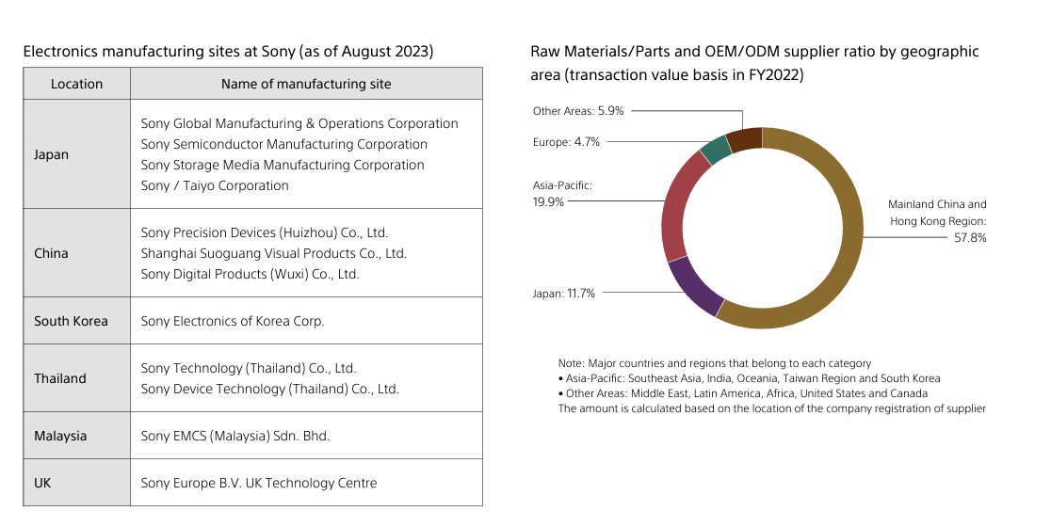

*Figure 2. Raw materials suppliers and transaction value as of Aug 2023 [3].*

Sony, moreover, maintains strategically-located warehouses and distribution hubs to ensure efficient logistics and supply chain management.

### 

### **1.4 Vertical Integration Level of Supply Chain**

Sony exhibits a moderate level of vertical integration, particularly in critical technology areas such as sensor and semiconductor production. This integration enables Sony to maintain high-quality standards and innovate rapidly. Their supply chain involves a blend of internal production and outsourcing, and several components are known to be outsourced at Sony. These include 20-30% of its imaging sensors, 20-30% of PlayStation console components, 30-50% of semiconductors, 40-60% of panels and chips for consumer electronics, and several others not publicly-available. Production of around 50% of Sony-branded accessories are produced by third-party manufacturers, and its logistics for transportation and storage of its products are outsourced as well [2]. An optimal compromise between internal versus external production at Sony has allowed enhanced efficiency across the company, and allows Sony to shift focus more towards core innovations.

### 

### **1.5 Company’s Primary Competitors**

In each product family across its diverse portfolios, Sony faces competition from completely different companies. In general, the largest of Sony’s competitors across its various business segments are Samsung, LG, Panasonic, and Apple. In the headphones market, Sony faces competition from companies like Apple, JBL, Bose, LG, and Beats, while it faces LG and Panasonic for TVs. The exact percentages of the market share can be seen in figure 3.

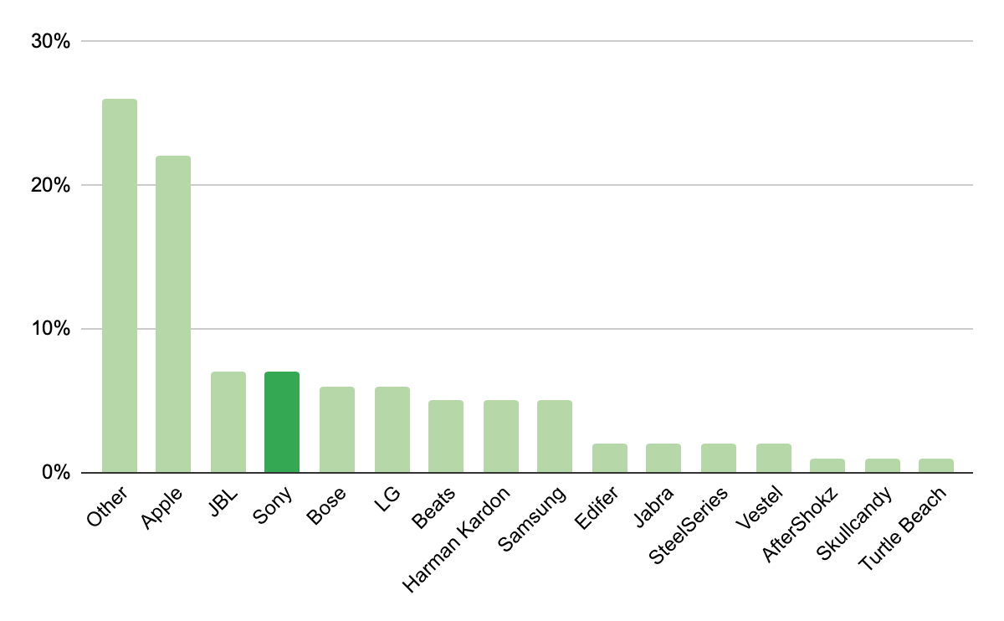

*Figure 3. Market share of headphones by brand [5].*

### **1.6 Current and Future Challenges**

There are three major current challenges that Sony recognises in today’s increasingly competitive market, and are combating systematically. The first challenge involves keeping up with the rapid current technological changes. To combat this, Sony is actively working on several innovative projects, including Capturing the Moment Technology, which enhances the customer’s ability to capture real-time experiences, Authenticity Verification Technology, which upgrades current solutions for authenticity, and Idea Realisation Technology, which would allow Sony to transform ideas into a reality near-instantaneously. The second challenge involves market competition, which Sony recognises as an ever-adapting problem that would require flexibility and insights to continue to innovate and adapt to market dynamics. The third challenge is supply chain disruptions, especially those that are unanticipated and unable to be predicted (e.g. epidemics, wars, natural disasters, etc.), and Sony intends to manage them through evaluating the risks associated with the current global supply chain first.

On the other hand, there exists generally three future challenges for Sony that it had implemented several solutions for in anticipation. The first is the world-wide goal of sustainability, which Sony aims to get ahead of the curve through fostering a culture of respecting diversity, equity, and inclusion, emphasising more the well-being of employees and creators, and promoting environmental awareness through social contributions and through its content IP. The second future challenge Sony recognises is AI and IoT integration, which Sony has been investing in building new ecosystems of connected products and services. The third is the expansion of 5G, which will provide Sony new opportunities to enhance its product offerings, particularly in areas of gaming, entertainment, and communications.

In recognition of these current and future challenges, Sony is pursuing a future direction where it will continue to maximise IP value and expand technology platforms for IP maximisation. These solutions include IP creation, cultivation, and extension, for which Sony termed the 360-degree IP Extension Model, which will allow Sony to explore new business models and further leverage its creative assets. The cutting-edge platforms in question to maximise the values of IP that Sony possess will include advancements in sensing and capturing technology, real-time 3D processing, AI and machine learning technologies, and engagement platforms to interact with consumers on a deeper level [6][7].

## 

## **2. Positioning of Sony and SONY WH-1000XM5**

### **2.1 Elements of Value**

Sony delivers value through multiple dimensions, as seen in its high-end products like the WH-1000XM5 headphones. These dimensions can be broken down into key areas that contribute to both functional and emotional benefits, along with aspects that enhance the user's sense of personal fulfilment. Here’s how Sony’s offerings align with different elements of value:

**Functional Value**

Quality: Sony is renowned for its high-quality [10] craftsmanship and audio performance, as demonstrated by the WH-1000XM5’s 40mm drivers and high-resolution sound capabilities. Sensory Appeal: The immersive sound, comfortable design, and sleek aesthetics enhance the user's overall sensory experience. Simplification of ecosystem: Features like multi-device connectivity and adaptive sound control make the headphones easy to use, reducing the need for manual adjustments and enhancing convenience.

**Emotional Value**

Reduces Anxiety & Wellness: The industry-leading noise-cancelling technology [9] offers peace in noisy environments, helping to reduce stress and improve well-being. Fun/Entertainment: The high-quality audio enriches entertainment experiences [11], making music, movies, and gaming more enjoyable. Self-Actualization: For audiophiles and tech enthusiasts, owning a premium product like the WH-1000XM5 fulfils personal desires for high performance and cutting-edge technology.

By addressing these elements of value, Sony ensures that its products, like the WH-1000XM5, provide more than just functional benefits, offering users emotional and personal fulfilment.

### **2.2 Product in Sony’s Ecosystem**

Sony’s ecosystem includes Integration with Other Devices, Enhanced User Experience, Wearable Technology, and IoT. The WH-1000XM5 headphones are part of this ecosystem, designed to work seamlessly with other Sony products. For example, the headphones support Sony's LDAC codec for high-quality audio when paired with Xperia smartphones or Walkman players, creating a cohesive audio experience across devices.

The WH-1000XM5 also integrates with smart assistants like Google Assistant and Amazon Alexa, enabling voice control. Its adaptive noise cancellation uses real-time data from Sony devices, enhancing personalization. As part of Sony's wearable technology and IoT strategy, the headphones offer smart features like adaptive sound control and gesture-based operation, reflecting Sony’s focus on connected devices.

## **3. Characteristics of SONY WH-1000XM5**

### 

### **3.1 Value Adding Network (VAN)** **[3][8]**

Value adding network for the Sony WH-1000XM5 can be roughly organised into categories of procurements, value adding operations, and distributions, which are detailed in figure 4. The raw material suppliers at the procurement stage provide inner electronic components, plastics, side-chemicals, and insulating materials. All of these components go through the diversified manufacturing and assembly processes to produce this headphone. The headphones are then distributed by Sony in official online stores, flagship stores, and with licensed redistributors.

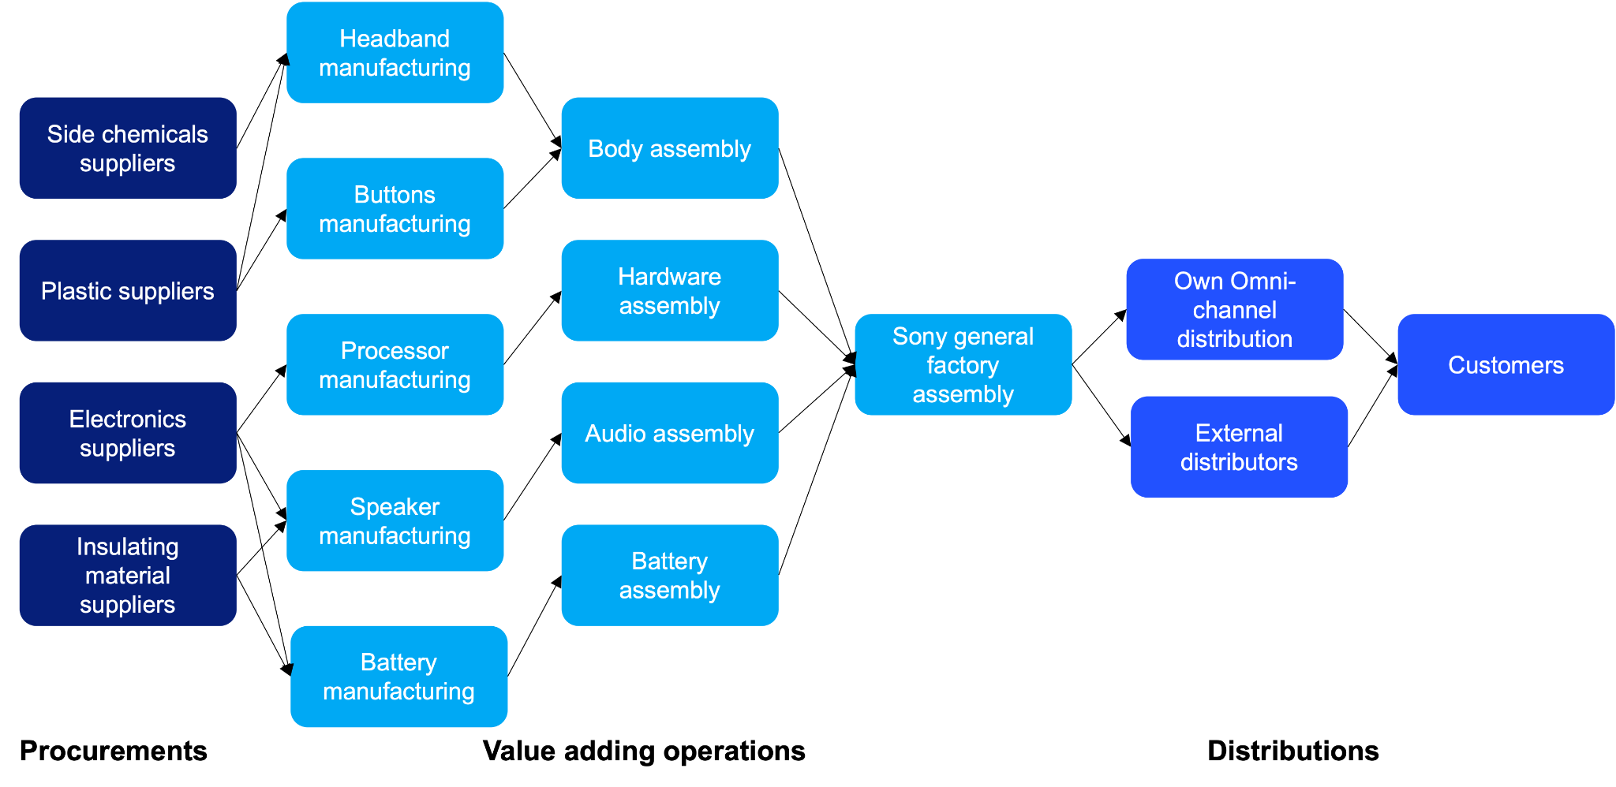

*Figure 4. Sony’s value adding network [source: team analysis].*

### **3.2 Material and Information Flows**

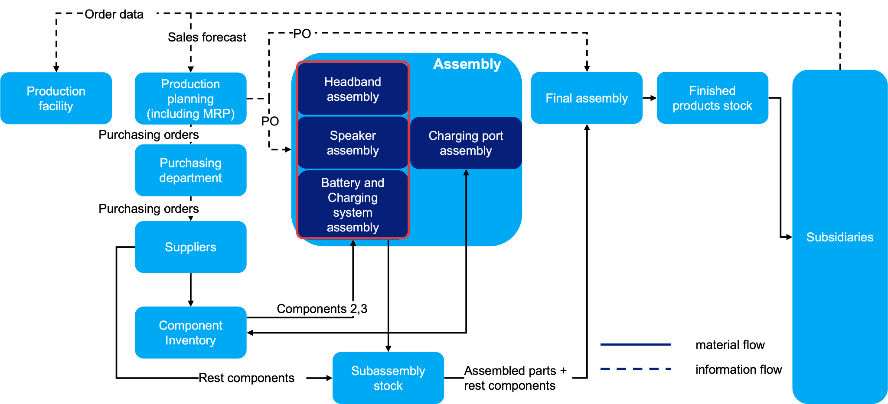

*Figure 5. Sony’s material and information flow network [source: PM classes input].*

Information Flow

Subsidiaries provide a monthly forecast per product family over a horizon of 12 months. Subsidiaries also send the order data to the main SONY factory according to their needs. The forecasts on each product family are consolidated by the Production Planning Team and used to create a monthly production plan. The Production Planning Team prepares a weekly Master Production Schedule (MPS) covering the next 12 months, based on the production plan and current order book. The Production Planning Team runs MRP every day and sends Production Orders (PO) to the Speaker Assembly Unit, Headband Assembly Unit and Battery and Charging Department. It also sends Purchase Orders to the Purchasing department. Purchasing places Purchase Orders to the suppliers as requested.

Material Flow

Suppliers deliver the ordered components that are necessary for the the Battery and Charging Systems (category 1) Team, Headband Assembly Team (category 2), and the Speaker Assembly Team (category 3) to the Component Inventory. Suppliers deliver the rest ordered components directly to the Subassembly Inventory. Charging circuitry and USB-C connectors are delivered from the Component Inventory to the Charging Port Assembly according to PO. Finalized charging ports are sent back to the Component Inventory. The components of categories 2 and 3 are delivered from Component Inventory to the Headband Assembly Team and the Battery and Charging Systems Assembly Team, respectively, according to the PO. Headband Assembly Team and Batteries and Charging Systems Assembly Team deliver the assembled headbands and electronics set to the Subassembly Inventory. The assembled parts, the components that belong to the Speaker Assembly Team, as well as Bluetooth Modules are all delivered from the Subassembly Inventory and then to the Final Assembly according to the PO. Assembled finished products are delivered from Final Assembly to Finished Product Inventory. Finished Products are delivered from the Finished Product Inventory to Subsidiaries according to their orders.

Material and Information flow are schematically depicted in figure 5.

### **3.3 Hierarchical Description of the Bill of Material (BoM)**

The materials required for creation of the product are schematically shown in figure 6.

Hierarchy level 1 consists of Headphone assembly, Battery and Charging Systems, Speakers Assembly, Bluetooth module. Hierarchy level 2 consists of Headband Frame, Cushioning Pads, Lithium-ion Battery, Charging Port, Voice call. Hierarchy level 3 consists of Charging Circuitry, USB-C Connector.

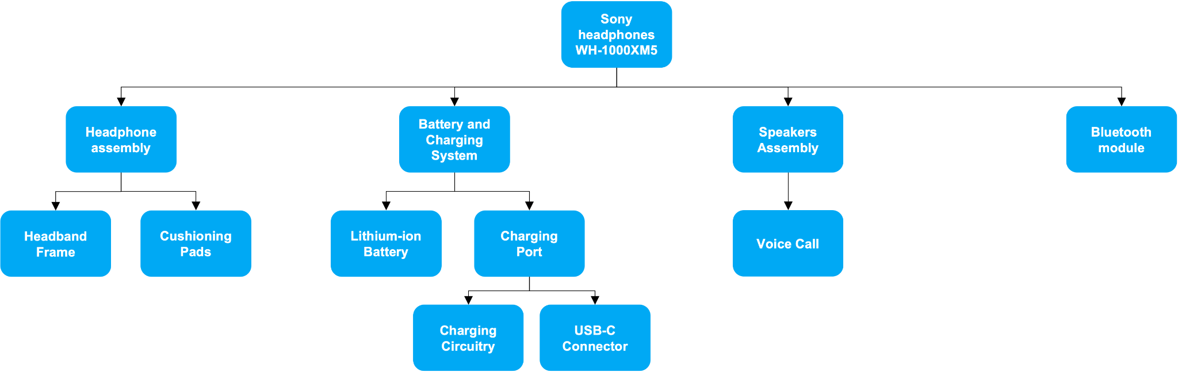

*Figure 6. Sony’s bill of materials. [source: PM classes input].*

## **4. Demand Forecast & Planning**

### **4.1 Introduction**

Demand planning for forecasting begins with analysing historical sales data for the Black and Silver versions of the SONY WH-1000XM5. The data has been cleaned to remove outliers using a confidence interval-based method, which was followed by data aggregation. Outliers were replaced by estimated sales values, determined using a nearest-neighbour approach, which takes an average between two closest records. In general, a consistent upward sales trend has been observed, with an average year-over-year (YoY) growth of approximately 5%. Additionally, recurring seasonal patterns were identified, with major sales peaks occurring annually in December or January, and local minima in March and August. These patterns will be further explored and extended as part of the upcoming forecasting analysis.

### **4.2 Goal of Forecasting and Assumptions**

In this forecasting report, the goal is to provide a better estimation of future events with reference to the historical data on two models of Sony noise-cancelling headphones. This report begins with the analysis of the data on the sales of SONY WH1000-MX5 Black and SONY WH1000-MX5 Silver. The goal is to determine and predict the possible future patterns of demand for both noise-cancelling headphones to enable Sony to allocate resources effectively, whether for material planning, marketing strategy, or risk mitigation. The company will be able to make decisions that maximize efficiency, reduce costs, and enhance overall performance. The sales data for each Sony headphone are extracted in the same time interval, and the sales on Saturday and Sunday are zero, in order to estimate demand over the five working days when the manufacturing centre of Sony is open.

### **4.3 Data Analysis**

### **4.3.1 Data Cleaning**

The data on the raw quantity of items of the Sony WH1000-MX5 Silver and Black has been collected over a period of 3.5 years, starting from the 1st of January 2021 to the 26th of September 2024 for both products. The first step in preparing the data is excluding potential outliers. Such procedures are followed to clean the data:

* Initially, the mean and standard deviation of the given data are calculated taking into account all available values.
* Next, the values were verified to lie within a certain confidence interval given by IC = Y ±1.96σY.
* Finally, all abnormal values outside the confidence interval are replaced with the mean of the two neighbour values.

This procedure is carried out two times to obtain more accurate results. For the Sony headphones black version - Figure 7 shows the cleaning procedure's results.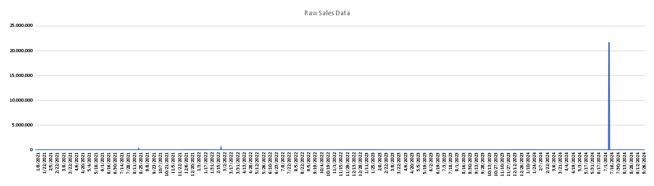

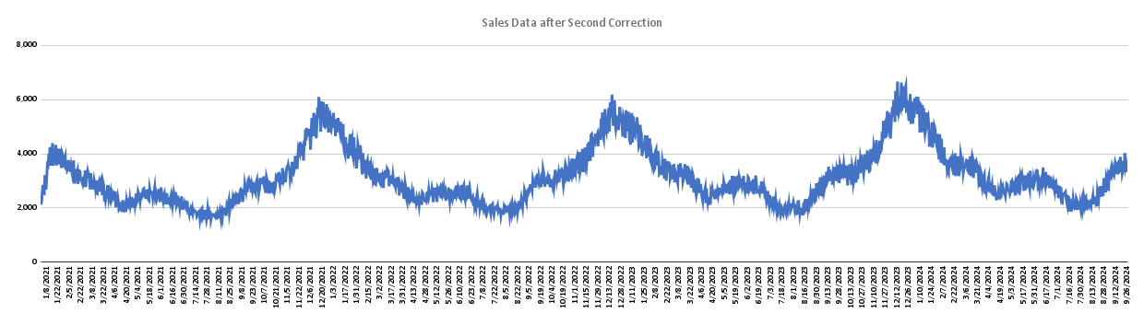

*Figure 7. Data cleaning process of Sony WH1000-MX5 black version [source: team analysis].*

Having cleaned off the outliers, the data shows obvious seasonality and a small trend that was harder to see before because of the suppression effects of the outliers. There is still some daily noise, but that doesn’t seem to impact very much the general slope and behaviour of the data.

### **4.3.2 Data Aggregation**

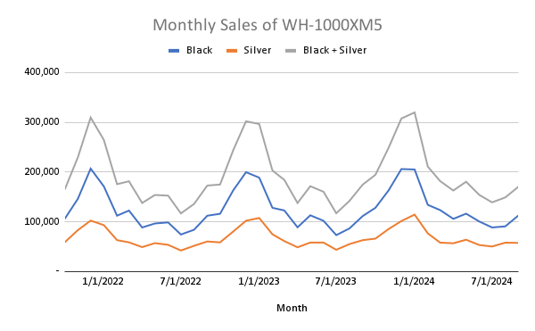

*Figure 8. Graph of monthly aggregated data of Sony WH1000-MX5 [source: team analysis].*

The next step consists of aggregating the cleaned data to forecast over a new time series. The aggregation is performed over each month. This new reference planning period offers cleaner visualisation, isn’t too restrictive, and avoids the noise seen in the previous shorter planning period. The data was also restricted to the last 36 months in order to have exactly 3 years to easily identify seasonalities and trends. In addition, a further data aggregation step was performed to encompass both colours of the Sony headphones. The seasonal behaviour remains the same as the total sales behaviour.

The comparison of graphs revealed that the sales of the WH-1000XM5 Black version significantly outpaced those of the Silver version, with approximately double the sales volume. Both versions exhibit the same seasonal sales patterns. However, it was also observed in our cleaned data that the Silver colour also exhibited annual growth of 12%, which was greater than that of the Black colour at 5%, suggesting a growing popularity for silver headphones. For the purposes of the analyses later on, we will focus only on the combined sales of both versions. The key objective is to evaluate the overall performance of the headphones, as the crucial insight lies in the total sales, rather than the specific colour trend at any given time.

### **4.3.3 Seasonality and Trend detection**

Sales data can reveal demand fluctuations in several distinct patterns, such as constant, cyclic, seasonal, and trending behaviors. Constant demand refers to relatively stable demand over a certain period. Cyclic demand, on the other hand, shows wave-like variations that span longer than a year in production graphs. Seasonality reflects regular short-term fluctuations, typically occurring on a monthly or weekly basis. A trend refers to a long-term increase or decrease in demand over time. When analyzing Figure 8, a slight upward trend can be observed, accompanied by seasonal volatility (with strong evidence of 12 months seasonality). Specifically, sales peak annually around December/January, followed by a decline from February through August each year.

To identify the most suitable model for analysis, two key steps are involved:

* Seasonality analysis
* Trend analysis

At first glance, Sony headphone sales show a slight upward trend. To confirm the growth trend, we calculate and plot a 12-month cyclic moving average and fit linear regression into the graph. The growth trend is confirmed because the coefficient of the linear regression has a positive slope, as can be clearly seen in Figure 9.

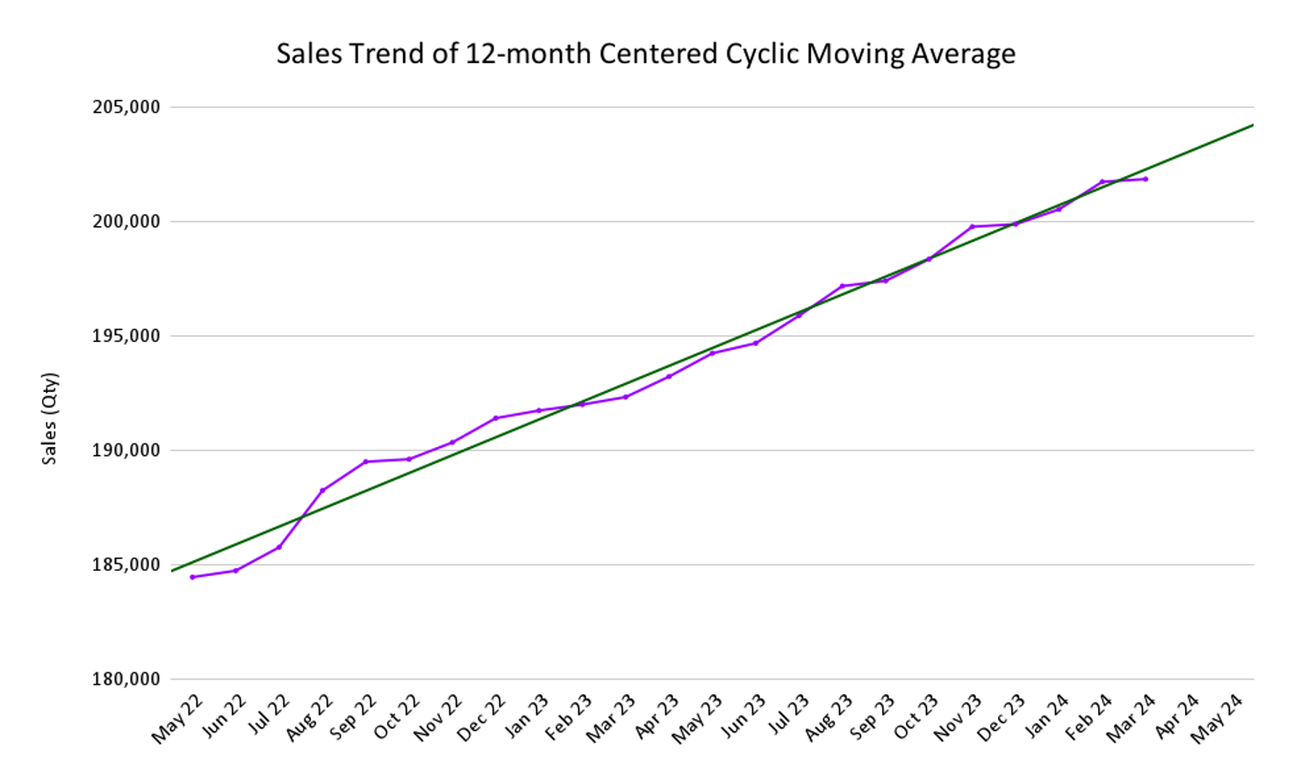

*Figure 9. Graph of 12-month centered cyclic moving average [source: team analysis].*

To determine the presence of seasonality and its period, an autocorrelation function (ACF) is calculated. This function measures the similarity of the data with a lag, which represents the shift in time (in months). For example, if the autocorrelation is near 1 at a 6-month lag, it indicates that the data repeats a similar pattern every six months. If the autocorrelation is close to -1, the behavior is the opposite six months apart.

There are two primary methods to analyze seasonality:

* Autocorrelation (ACF)
* Cross-correlation with itself

Both methods were leveraged in this analysis. To calculate cross correlation we used the Excel formula CORREL, while for the autocorrelation we used specified formula with a lag of $k$.

|  | $r_{k}:$*auto-correlation coefficient Ȳ $k :$*  *time lag $Ȳ :$*  *mean value of aggregated data $Y_{t+k} :$*  *aggregated data at period t shifted by k* |
| --- | --- |

*Figure 10. Autocorrelation formula*

The main difference between these methods lies in the denominator used and how they iterate through different segments of the dataset. The graph below illustrates the seasonality analysis results using both approaches:

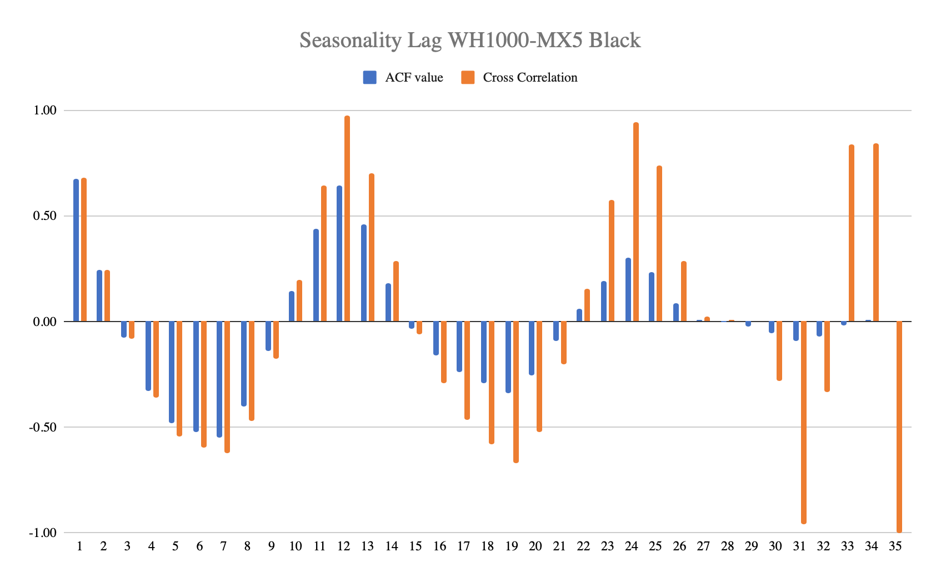

*Figure 11. Graph of ACF values and Cross Correlation values for different Lags [source: team analysis].*

The highest autocorrelation coefficient occurs at a lag of 12 months, confirming the presence of 12-month seasonality. While it was visible in advance, the results provide statistical evidence to support the conclusion. Additionally, for lags between 4-8 months, the autocorrelation is negative, indicating that the data behaves oppositely in the second half of the year compared to the first half.

### **4.3.4 Preliminary forecast model**

Forecasting Sony headphone sales demands a well-structured and accurate model. The process begins with model initiation, which lays a solid foundation for developing a reliable rolling forecast. This initiation phase ensures that the forecasting model is built on a systematic and data-driven approach.

Analysis of the autocorrelation reveals a clear 12-month seasonality in the data. Consequently, following the decision framework illustrated in Figure 12, the Holt-Winters model is selected as the forecasting method. By examining the aggregated data, and closely analyzing both the trends and the amplitude of seasonal peaks, the model is configured to use an additive trend and multiplicative seasonality [a,m]. This combination effectively captures the evolving sales trends while accounting for seasonal variations that change in magnitude over time.

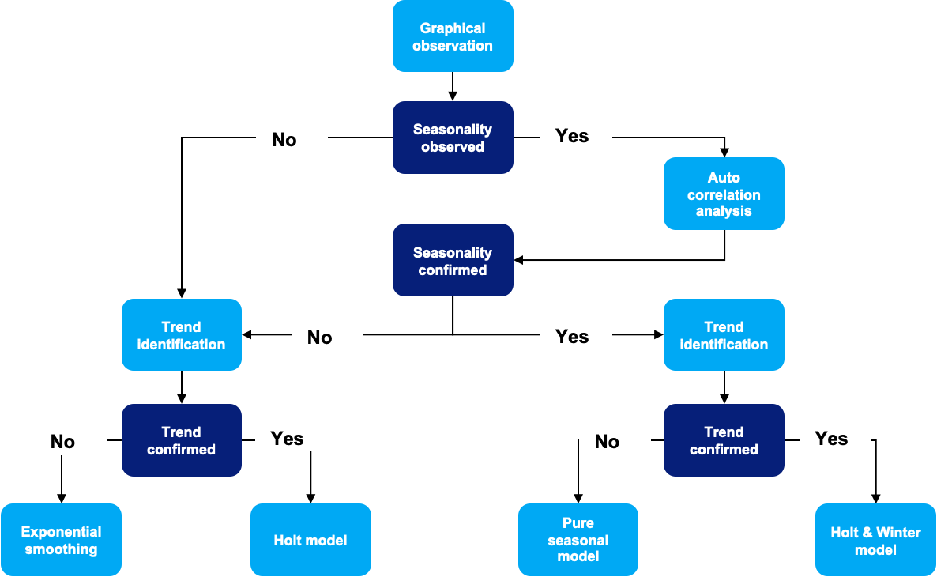

*Figure 12. Decision flowchart for forecasting model selection [13].*

To begin with the Holt-Winters model, we must first establish the key initiation components:

1. Identification of the initial trend (T')
2. Identification of the initial seasonal components (S')
3. Identification of the initial base (B')
4. Development of the initial forecasting model (F')

Finally, the forecasting model is validated using a reliability measure, specifically the Mean Absolute Percentage Error (MAPE’), to assess its predictive accuracy.

The data used for this process consists of aggregated sales from the past three years, spanning from October 2021 to September 2024. These three years are segmented into cycles, each containing 12 months. The process begins by calculating the initial trend (T'), using a cycle moving average with a periodicity of 12 months (c=12), as indicated by the seasonal pattern. This moving average is computed across all three cycles, helping to identify long-term sales patterns. By applying linear regression to the cycle moving average, we derive the initial trend, which provides insights into the underlying growth (in our case) in sales over time.

Next, we calculate the initial seasonal components by determining the average for each cycle. Using these cycle averages, we then adjust the data to create a deseasonalized time series. This step allows us to uncover the underlying patterns without the influence of seasonality. These averages help define the seasonal components needed for the model.

The initial base (B') is then calculated, focusing on the middle cycle to balance the influence of early and late data. This base is computed by averaging the values of the middle cycle, adjusting for the initial trend component, and representing the fundamental level of sales around which seasonality and trend variations occur. With the initial trend, seasonality, and base components in place, an initial forecasting model (F') is constructed. This model is applied to the third financial cycle to then be tested with the actual data.

To validate the forecasting model, we use the Mean Absolute Percentage Error (MAPE’), which measures the accuracy of the model's predictions by comparing the forecasted values with the actual sales data. MAPE’ provides a reliable metric for assessing how well the model performs, ensuring that it can be trusted to deliver accurate sales forecasts.

**4.3.5 Forecasting stage**

After initializing the model, the forecast is rolled out across the data up to the end of the second financial cycle. Based on performance, it was decided to include the first cycle as well. For each forecast, the base, trend, and seasonal components are updated monthly using the Holt-Winters model.

For fair MAPE validation, the forecast is rolled on the last 3 cycles and the performance is analysed. Since, there is not any actual data for the cycle, the last known base with the last trend and increment the "h" are used. This h is 1, after the first month and 12 for the last one, the seasonality just uses the last calculated seasonality.

In our case, the initial values were determined as follows:

* Trend Initial (T₀) = 789
* Base initial (B₀) = 197,147
* Seasonality initial (S₀) =

| Lag | S₀ |
| --- | --- |
| **1** | 0.92 |
| **2** | 1.28 |
| **3** | 1.72 |
| **4** | 1.46 |
| **5** | 0.97 |
| **6** | 0.99 |
| **7** | 0.75 |
| **8** | 0.84 |
| **9** | 0.83 |
| **10** | 0.63 |
| **11** | 0.73 |
| **12** | 0.92 |

Using:

|  |  |
| --- | --- |

*Figure 13. Formulas used to determine B0.*

The forecast is then executed using the Holt-Winters model, applying the following formulas and initial values for the first month.

|  | Initialisation parameters: |
| --- | --- |

*Figure 14. Formulas used for forecasting with the Holt-Winters model.*

The seasonality component (S’) is predicted using a time series model. Seasonality for cycle 1 is weighted, cycle 2 seasonality is derived from cycle 1, and cycle 3 seasonality is based on cycle 2.

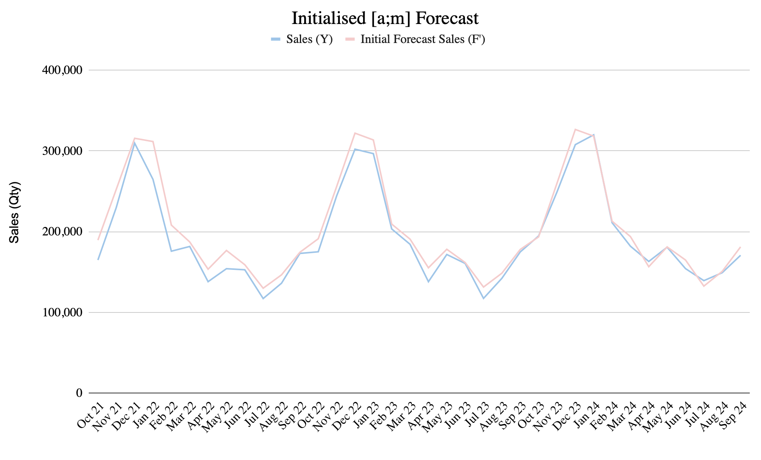

*Figure 15. Plot of the forecast of the 3 cycles. [source: team analysis]*

The initial forecast (h=1) shows a strong alignment with actual sales, though some errors are present. These errors are calculated and plotted over time as absolute percentage errors (APE’). Values for the Initial Forecast and APE can be seen in Figure 15 and Figure 16. This is not an actual validation procedure but is only used to have an internal understanding of how well the model is able to fit the data. The proper validation procedure is carried only on cycle 3.

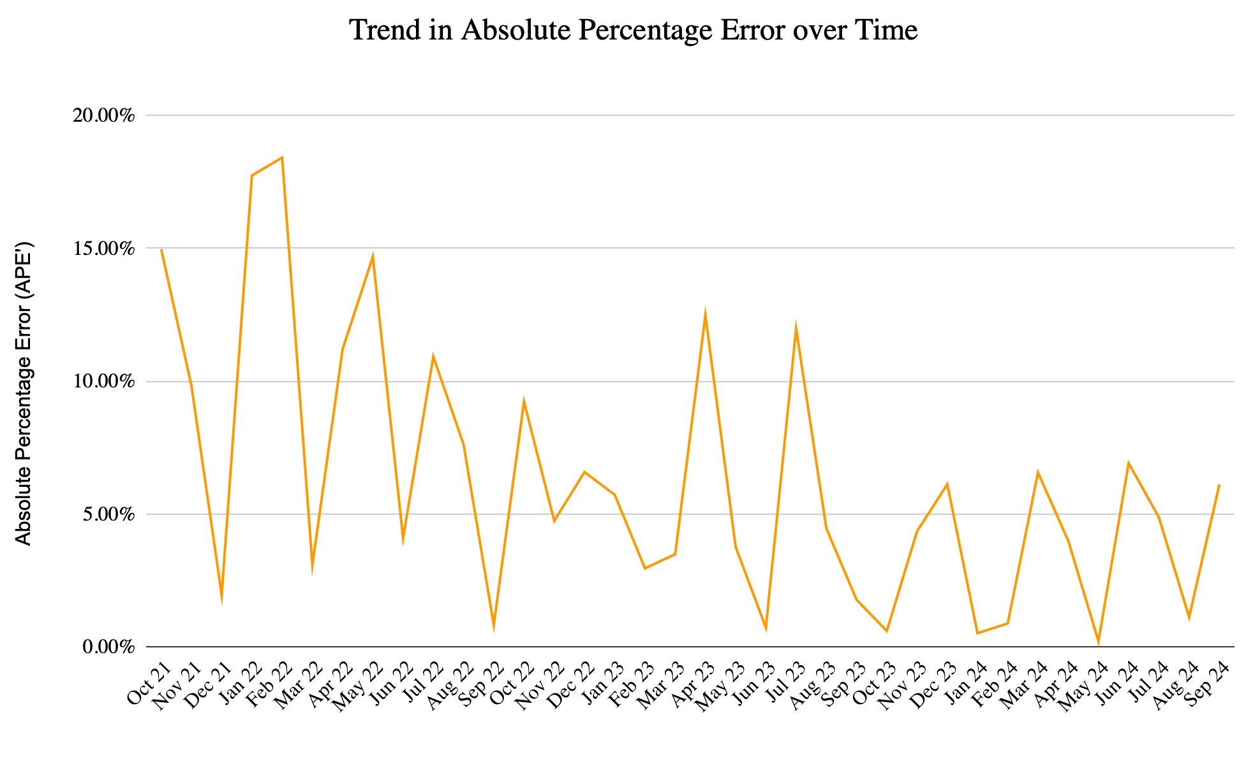

*Figure 16. Plot of the Absolute Percentage Error over time. [source: team analysis]*

To validate the model using MAPE, as mentioned above by varying h, that is h = 1, after the first month and 12 for the last one. When the model is validated, we proceed to forecast the next 18 months based on the previous 24 months of data (12 months from September 2023 - October 2024 are used for validation and not shown to the model. The MAPE achieved on validation is 3.99%). We anticipate continued upward trends with the intrinsic seasonality maintained. Figure 17 demonstrates that the model predictions are consistent with historical trends and seasonality.

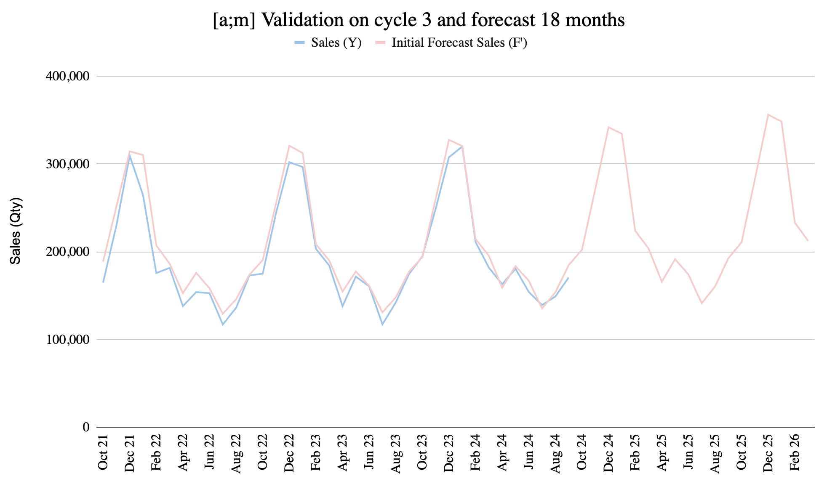

*Figure 17. Plot of the Validation on cycle 3 and forecast of the following 18 months. [source: team analysis]*

**4.3.6 Parameter optimization**

To optimize the parameters α(alpha) and β(beta), we evaluated the Mean Absolute Percentage Error (MAPE) over a moving average period. Our approach involves a 12-month rolling cycle, repeated five times, to calculate an average MAPE value. This rolling evaluation helps smooth out short-term variations and provides a clearer indication of model performance over time. When tuning the Holt-Winters model, adjusting α and β is crucial, as these parameters directly affect the model's level and trend components. These components are fundamental in capturing long-term trends and underlying patterns in the data, which directly influences the forecast's accuracy. In this analysis, the seasonal component parameter γ (gamma) is fixed at a commonly accepted industry standard of 0.8, given that the seasonal patterns in the data are stable and predictable. Fixing γ allows us to focus solely on optimizing α and β, simplifying the optimization process without compromising model accuracy.

One significant adjustment in our approach compared to previous studies is in the range and scaling of α and β. After observing that MAPE values increased sharply for higher values of these parameters, we confined our parameter search to smaller values. This modification avoids excessive error magnitudes at high parameter values and ensures that we capture the most stable, optimized settings for α and β. The initial grid had values from 0 to 1 linearly, but it turned out that values for α and β more than 0.01, MAPE had much bigger values (apart from diagonal) and therefore, the grid was adjusted. The minimum is set at 0.001, and the maximum (0.09) remains within a manageable bound that allows for efficient computation and meaningful interpretation of results.

The optimal parameter combination, yielding the lowest MAPE of 3.78%, was achieved with α=0.001 and β=0.003. This low MAPE indicates that the forecast model is highly accurate, reflecting a minimal average deviation between predicted and actual values. Such accuracy is expected in this case, as this is an idealized dataset using simulated demand data rather than real-world figures. The demand values in this dataset are less volatile and inherently easier to predict, allowing for an exceptionally precise forecast.

In a real-world application, forecast accuracy would likely be lower due to the increased variability and unpredictability of actual demand patterns. On top of it, in real-world applications, selecting such small values for α and β parameters can have a negative impact on model performance in the future. Due to the fact that the historical data is very stable, and doesn’t need a lot of adaptation, the optimized α and β parameters are close to zero. If we needed to apply the algorithm to real-world data and test the quality of the forecast in the real-world setting, we would prefer model robustness and adaptability over mathematically optimized validation score and likely restrictions of type α and β > 0.05 would be imposed. We would also perform robustness analysis to select parameters in the real-world set up.

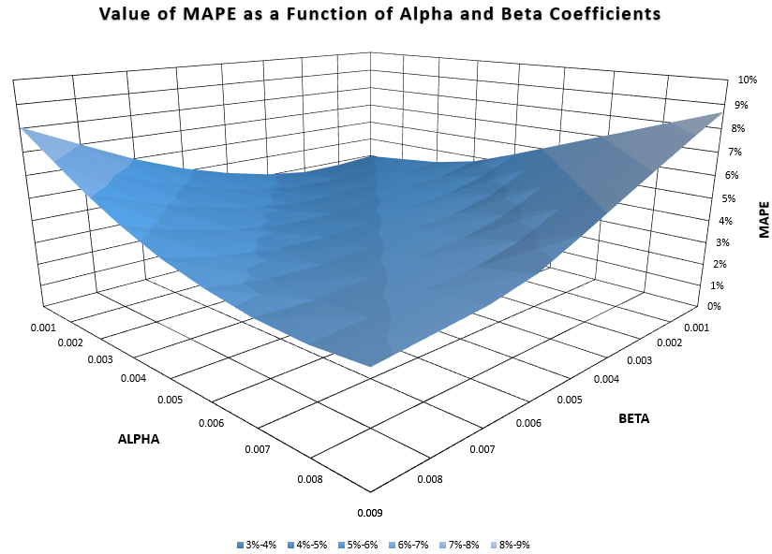

*Figure 18. Contour plot of the values of MAPE in terms of α and β. [source: team analysis]*

Now with the optimised values for alpha, beta, and gamma, we ran the sales number with the Holt-Winters Model to forecast sales demand for the next 1.5 cycles (next 18 months).

*Figure 19. Optimized forecasting of sales demand with Holt-Winters Model. [source: team analysis]*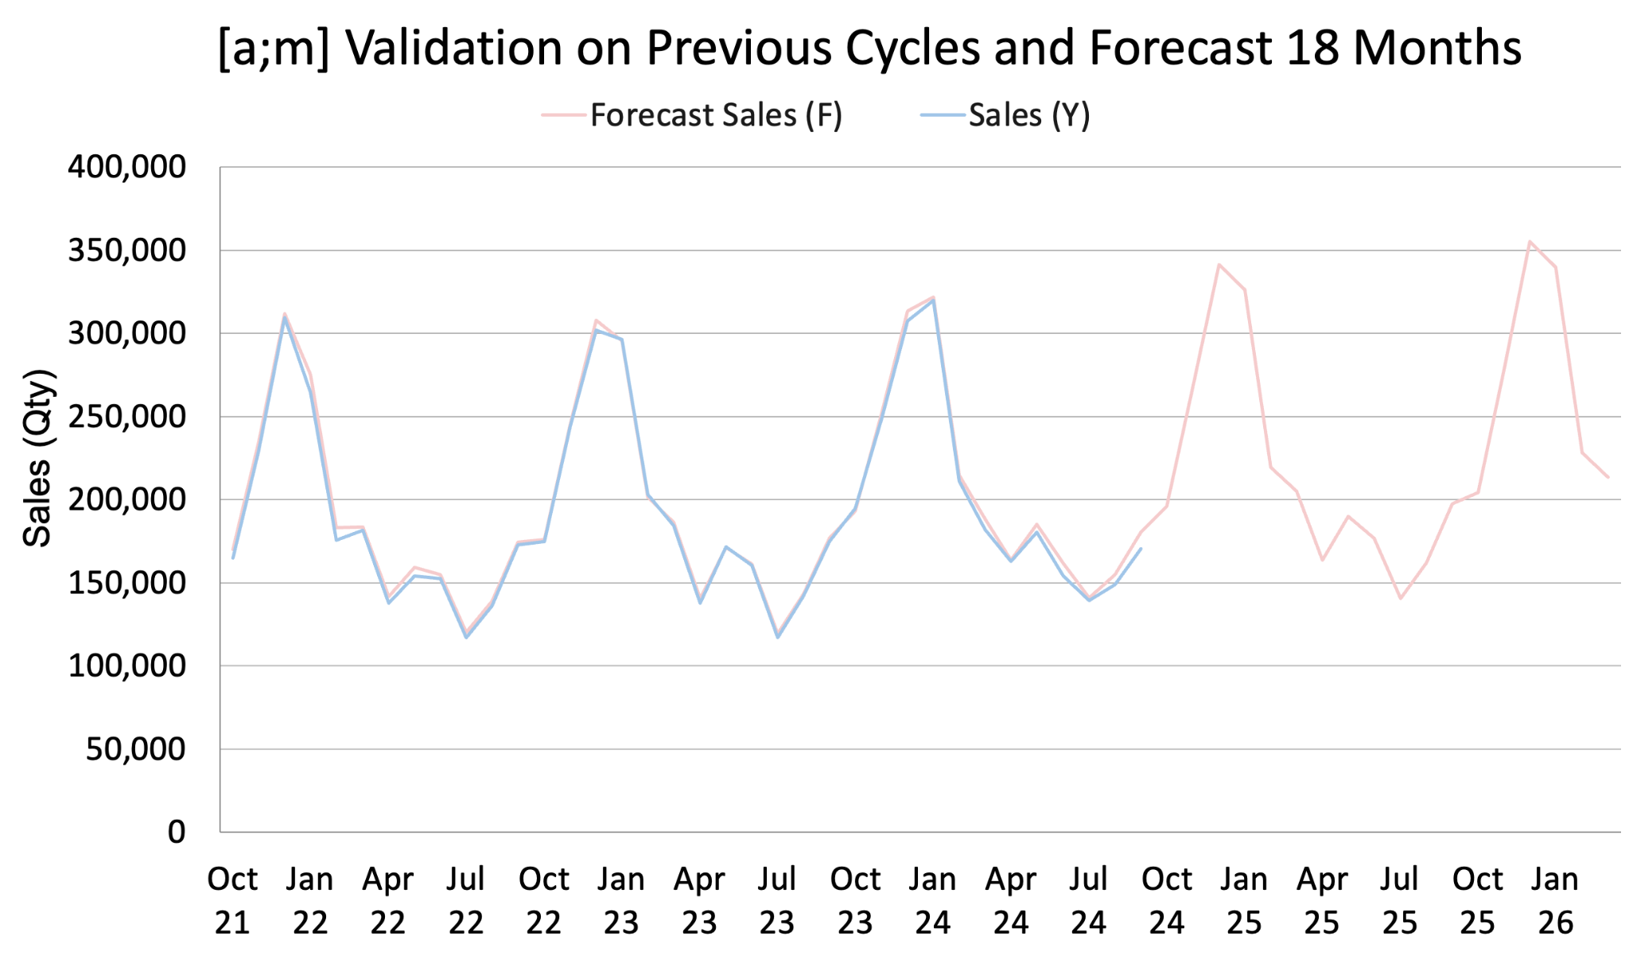

## **5. Production Planning**

### **5.1 Introduction**

Production planning is a critical next step following our demand forecast for the Black and Silver versions of the SONY WH-1000XM5 headphones. With demand projections now in hand, our focus shifts to ensuring that production can meet the anticipated sales volumes effectively. In this section, we will assess if Sony's current manufacturing capacity aligns with the forecasted demand, determine necessary adjustments, and develop an authorized Master Production Schedule (MPS) to support efficient supply. Through this process, we aim to refine Sony's supply planning capabilities by establishing an accurate MPS and designing a Material Requirements Planning (MRP) system, testing out both the Economic Order Quantity (EOQ) and the Economic Production Quantity (EPQ) model for inventory management, choosing the right discount and Security Stock (SS) model. By aligning production and inventory management with demand, this planning phase will enable us to fulfill forecasted sales in a cost-effective and timely manner.

### **5.2 Aggregate Plan**

An Aggregate Plan (AP) provides a structured, overview approach for managing Sony’s production resources to meet the anticipated demand for the Black and Silver versions of the SONY WH-1000XM5 headphones. This plan balances workforce, production, and inventory levels to achieve cost efficiency and reliable fulfillment of the forecasted demand, and this is done on a monthly level. To accommodate seasonal fluctuations, we plan for workforce increases and overtime utilization during peak demand periods (October to February). This strategy ensures production capacity meets demand without long-term workforce expansion, enabling a flexible response to changes in the sales cycle.

### **5.2.1 Initial conditions**

Beginning inventory was defined as the average sales across the entirety of cycle 3. This average of sales irregardless of seasonality allows us to predict the size of workforce to deal with this year-on demand, for which we assumed 2150 workers for the start of cycle 4. Labor units per worker were difficult to estimate, as Sony does not publicly release these data. We decided to derive this number for Sony based on Apple AirPods, which has around 3 million units sold per month with a requirement of around 30,000 workers to accomplish this goal for highly automated manufacturing lines. Assuming these numbers are correct, and the 30,000 accounts for ideal production schedules with no backups, this will equate to 100 units per worker. For higher quality headphones (e.g. noise cancellation), the production will roughly be around 100~150 units per worker, while low-end products from other companies can reach 200~350 units per worker. Given these facts, we have decided to go with 100 units per worker, assuming a highly automated manufacturing line, and assuming the beginning workforce will be 5% more than this ideal production schedule to account for sickness, injuries, and individual productivity differences.

### **5.2.2 Cost analysis**

The following costs per unit were determined to optimize workforce and inventory management while meeting projected demand:

* **Regular Time Labor Cost**: Calculated at $5.00 per unit, assuming an average wage rate in Sony’s Southeast Asia production facilities. This rate is based on full-time employment (160 hours per month) and an average hourly wage of $3.
* **Overtime/Subcontracting Cost**: Set at $9.00 per unit, reflecting a 180% wage rate for overtime. This is the average between 150% on the more economical end and 200% on the more premium and high-quality end of industry standards.
* **Inventory Holding Cost**: Estimated at $5.00 per unit. This value is on the high end of regional storage costs, factoring in costs from capital, warehousing, insurance, labour, and depreciation (not high for Sony’s products).
* **Backorder Cost**: Priced at $10.00 per unit, this cost includes additional inventory costs, overtime/ subcontracting costs, and lost potential revenue.
* **Hiring Cost**: Fixed at $500.00 per employee, which covers training, administrative processing, and onboarding expenses.
* **Layoff Cost**: Estimated at $800.00 per employee, which we set as 2.5 weeks of severance pay.

### **5.2.3 Aggregated Plan strategy selection**

There are three types of AP plans we tested for: level, chase. and hybrid. For Level AP, we kept the same workforce from last year with immediate hiring of 300 people in October. For Chase AP, we have decided to hire or lay off workers based on the demand of the month and what is in our inventory currently, and this number is assumed that by the first day of the month, this number of workers will be hired. For Hybrid AP, we will subcontract additional 400 workers as of November based on our forecasted year-on average demand to cover the peak demand and end the subcontracts of 500 workers as of April when the demand is low. Analysing the production strategy of each plan as a function of demand, as well as the total (cumulative) monthly costs, which takes in account all the costs associated with regular time/ overtime capacity, backorders, workers hired, and workers laid off, we

*Figure 20. Comparison between different AP production strategy versus forecasted demand. [source: team analysis]cu*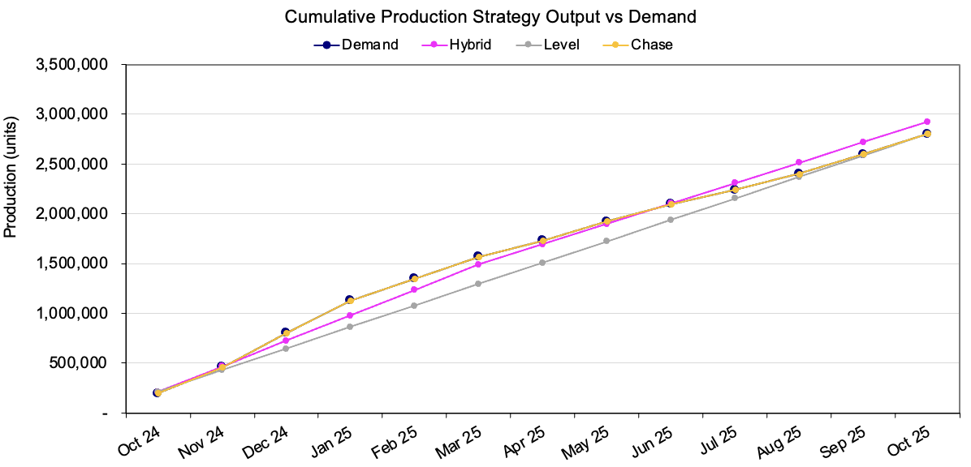

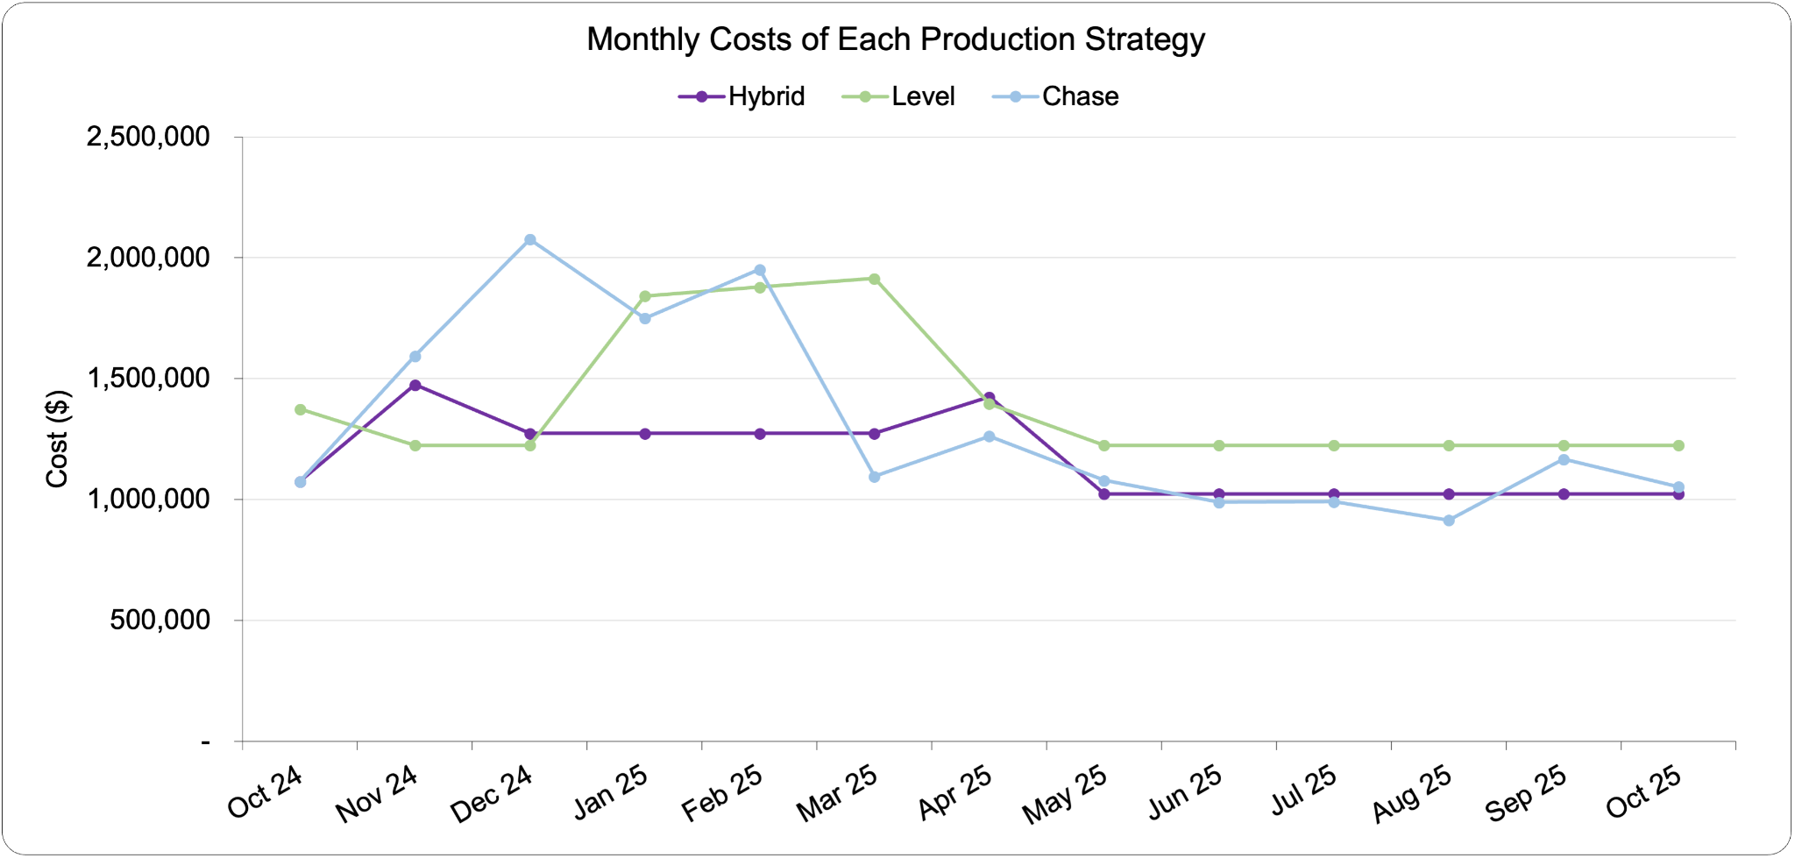

*Figure 21. Total monthly costs of each AP production strategy. [source: team analysis]*

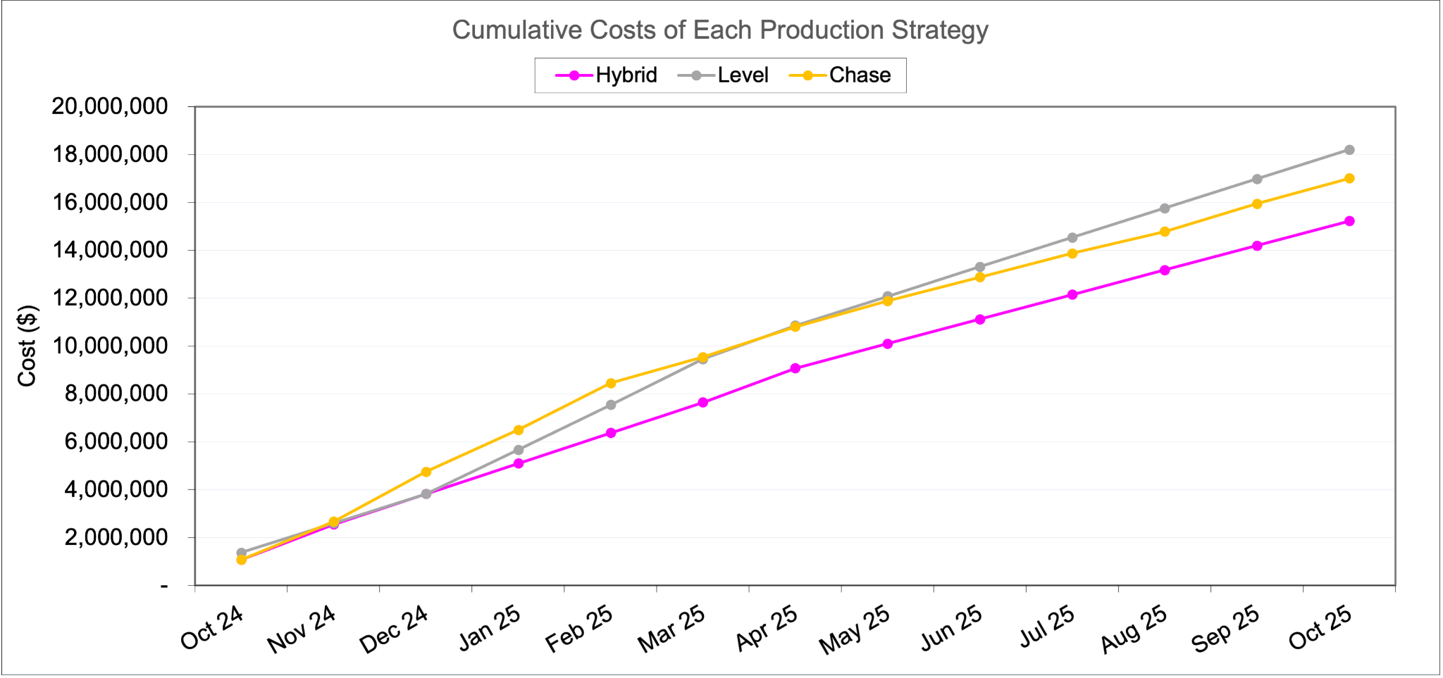

*Figure 22. Cumulative monthly costs of each AP production strategy. [source: team analysis]*

can see that the Level AP, i.e. previous cycle’s workforce, have the highest monthly costs out of all the other strategies due to overtime and backorders. Chase AP follows the demand the best and has moderate monthly costs, but for this particular industry, hiring and firing at the rate we were projecting will actually be detrimental to production and the morale of the workers. Alternatively, the Hybrid AP, where we subcontract for half-year enough workers at the beginning of the cycle to fulfill the forecasted peak demand, then has a moderate monthly cost over time, and therefore, we have opted to pursue MPS with Hybrid AP. Cumulative costs and production along with monthly costs per scenario can be seen in Figures 20-22. From the points mentioned above, we conclude to go with Hybrid AP, due to moderate costs, and good HR image of the company (no extensive hiring/firing of the people)

### **5.3 Master Production Schedule (MPS)**

Unlike AP, MPS reveals production planning on a weekly level, allowing us to allocate resources according to incoming order demands. From this MPS, we will be able to obtain a Rough Cut Capacity Planning (RCCP) to anticipate and roughly evaluate labour required to meet the MPS.

For this part we allocated the forecasted demand from month to week level. Rather a simplistic approach of dividing the month by 4 weeks to approximate a year as 48 weeks is used. It is estimated that the beginning inventory equals the average of monthly demand, aiming for approximately one month’s inventory, the security inventory is assumed to be 20% the beginning inventory.

The primary requirement for the initial MPS is to ensure sufficient shipment of WH-1000XM to meet customer orders. The Initial MPS is aligned with the forecasted demand, yet it does not factor in production force constraints (assuming the production by 1000 units per batch, MPS will be divisible by that number). The resulting pattern is large as anticipated, with the customary demand spikes observed in December and January, as well as during weeks with high customer orders.

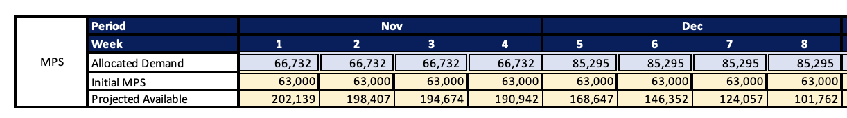

*Figure 23. Initial MPS under Hybrid AP for November and December 2024. [source: team analysis]*

### **5.3.1 Authorised MPS**

The customer orders were provided as an example scenario, and this represents the actual demand, in contrast to the forecasted order planned through the AP. We have a requested order of 230,000 units for the month of November, 312,000 units for the month of December, 274,000 units for the month of January, and the order of 401,000 units was declined, as we can only allocate it by spreading across a 7-week period, which is too much. For the subsequent months, MPS was allocated based on monthly forecasted demand spread out evenly over four weeks per month. For the months of November to March, the orders were manually reallocated over 4 weeks or over 8 weeks based on three things: 1) balance out MPS such that the workload is evenly distributed across the weeks, and 2) ensure products Available to Promise (ATP) remains above zero. Figure 24 depicts the progression of this trend. As MPS fluctuates around the weekly demand, the projected available and ATP drops significantly. This may pose a problem for additional unanticipated orders, but as a company, we should, in principle, operate under ATP. Formulas used for Authorised MPS calculation

PA = beginning inventory (subsequently, previous PA) + authorised MPS - MAX(sales forecast, customer orders).

Similarly, we can calculate the number of units that we have that are Available to Promise (ATP)

ATP = authorised MPS - reallocated orders. And for the first week, the Initial Inventory is added.

It can also be seen that inventory at the end of cycle returns close to initial inventory level, highlighting the consistency and correctness of specified modelling procedure. In the later stage, when the effect of additional customer order is neglected the Authorised MPS coincides with ATP.

Figure 25 demonstrates the dynamics of the utilization rate of our workforce. It’s two constant values, the difference is caused by the ending of the subcontract for the workers as of beginning of the April (low demand period)

*Figure 24. Authorised MPS under Hybrid AP. [source: team analysis]*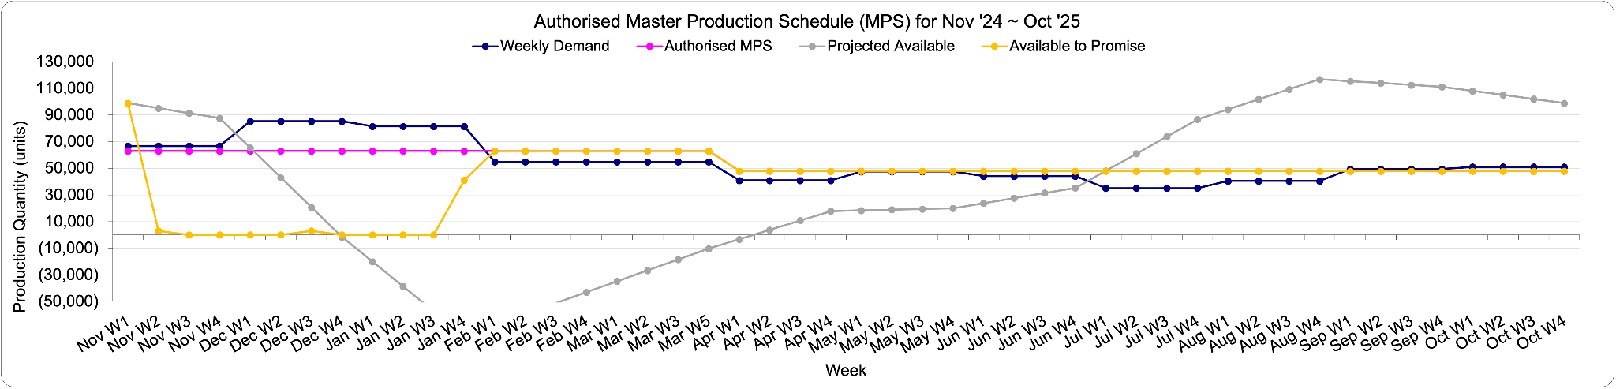

*Figure 25. Utilization rate in Authorised MPS under Hybrid AP. [source: team analysis]*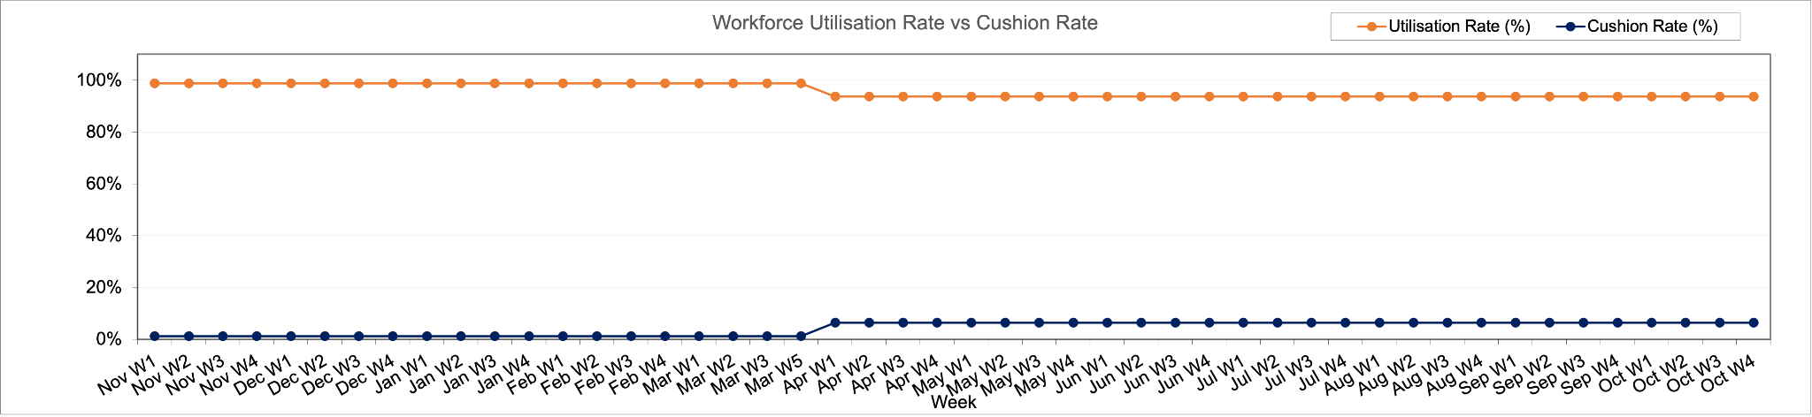

### **5.3.2 RCCP**

With the MPS determined, RCCP can be set as well. And as Figure 26 showed, because of the implementation of the Hybrid AP, we have two constant levels of available labour units throughout the projected year, with fluctuating required labour units based on MPS. RCCP analysis reveals that the available labour units lie on the mean of the required labour units depending on seasonality:

*Figure 26. Authorised RCCP under Hybrid AP. [source: team analysis]*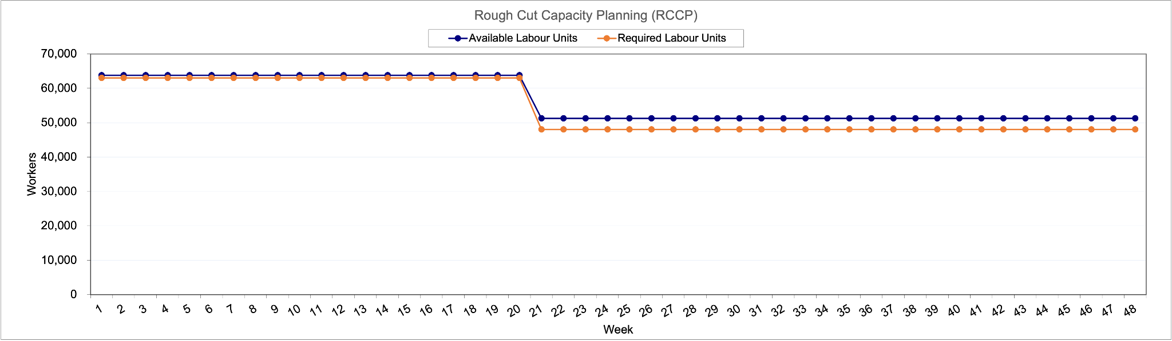

during high-demand seasons in the winter, available labour falls behind required labour; but during low season, available labour is higher than required labour. This falls in line with what the chosen Hybrid AP was designed for, which was to have both the inventory stock (ATP) and the constant amount of workforce (within each half-year period) to fulfill the higher volume of orders during high season and have the constant workforce to fulfill the much lower volume of orders and replenish the inventory during low season. That is quite visibly demonstrated in Figure 26, where Available workforce and required workforce are compared.

### **5.4 Material Requirement Planning (MRP)**

Here we took the provided BoM to generate our MRP, which lays out our plan to purchase the materials required to assemble the final product, taking into account lead times and their individual quantities. Instead of considering the entire complex network of BoM, we took one flow of material as an example, where the product (level 0) was assembled from level 1 through 3 components:

WH-1000XMS → Battery & Charging → Charging Ports → Charging Circuitry x2.

Knowing the lead times of each component and knowing whether Sony purchases these components on a lot-for-lot (L4L, ordering whenever needed), fixed order quantity (FOQ, irregular fixed amount), or a period order quantity basis (POQ, regular fixed amount), we were able to assemble the MRP. Specifically, we know that the Level 0 (the product) has a 1 week lead time on an L4L policy, Level 1 has a 1 week lead time on a POQ policy every two weeks, Level 2 has a 3 week lead time on an L4L policy, and Level 3 has a 2 week lead time on a FOQ policy of 10,000 units. This allows us to visualise the project available amounts of each component as a function of time.

*Figure 27. Selected MRP for the production. [source: team analysis]*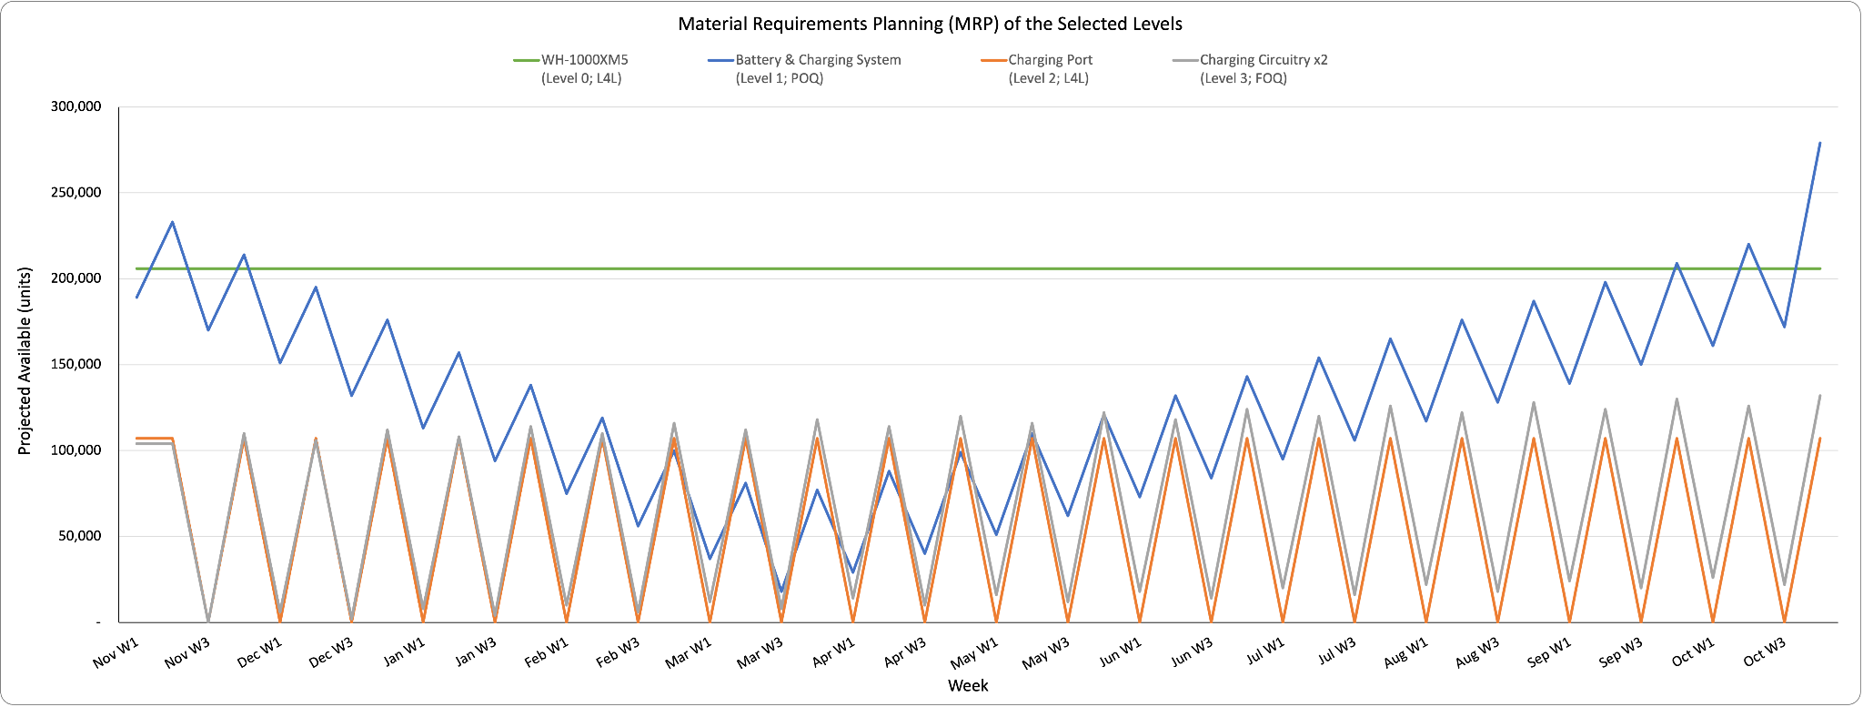

Visualising the change in component availability over time in Figure 27, we can see that although the final product WH-1000XM levels remain the same, all the other daughter components fluctuate with time based on the lead times and the purchase policies. In reality, the amount ordered for these components has to take into account a baseline security stock in order to avoid running out of any components.

### **5.5 Economic Ordering / Production Quantity**

The laid-out MRP tells us the amounts that are required to maintain a stable level of production of our final product, but it lacks information specifically on the cost associated with the purchase of these components. In order to model this and determine the best quantity to order the components, we tested out the Economic Ordering Quantity (EOQ) of the four levels of components, as well as the Economic Production Quantity (EPQ) for the final product. EOQ and EPQ are usually used to differentiate between components that are purchased from suppliers or components that can be made in-house, respectively.

### **5.5.1 EOQ**

In order to determine the optimal EOQ, we take into account inventory depletion rates measured against holding and ordering costs. To calculate this, we take the annual demand and lead times from MRP, and the ordering and holding costs defined in AP. Thus, the EOQ (Q) can be calculated as below, with the total cost (TC) also able to be calculated as a function of demand (D), Q, ordering cost (S), and holding cost (H):

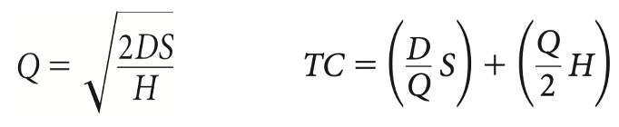

If we vary Q in a stepwise fashion, it can also allow us to plot TC, S, and H to give us a visual representation as to when the S and H intersect, which can also give us the EOQ. The EOQ of Level 0 is 16,137 units (depicted in figure 28), Level 1 is 22,821 units, Level 2 is 41,665 units, and Level 3 38,575 units.

*Figure 28. Modeling of EOQ for WH-1000XM. [source: team analysis]*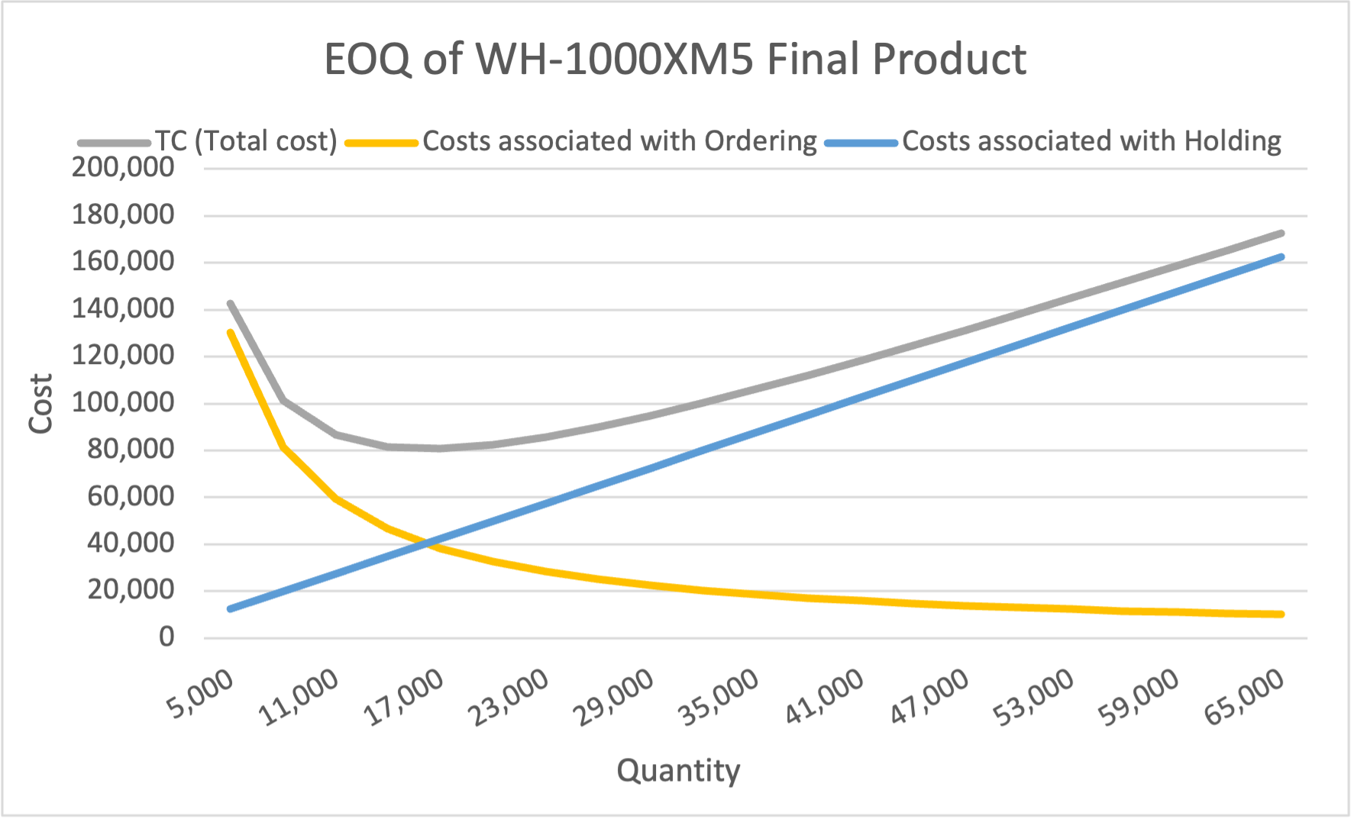

The sharp drop in cost at lower quantities and its slow return can be best interpreted that the more you need a subcomponent, the more storage space that is required, and thus, higher holding costs. In cases of smaller components, because it costs the same to order as bigger ones, and that it costs less to hold per unit due to its size, they end up costing less at higher quantities. It means that Sony should order small quantities very often, which may be true, and more validation is needed to confirm this.

### **5.5.2 EPQ**

To calculate EPQ, in addition to the values set from EOQ, we would need production rate, determined through dividing the annual production rate by the number of working days for all component levels. Specifically for the EPQ of the final product, it was calculated to be 78,140 units, and can be visualised in figure 29.

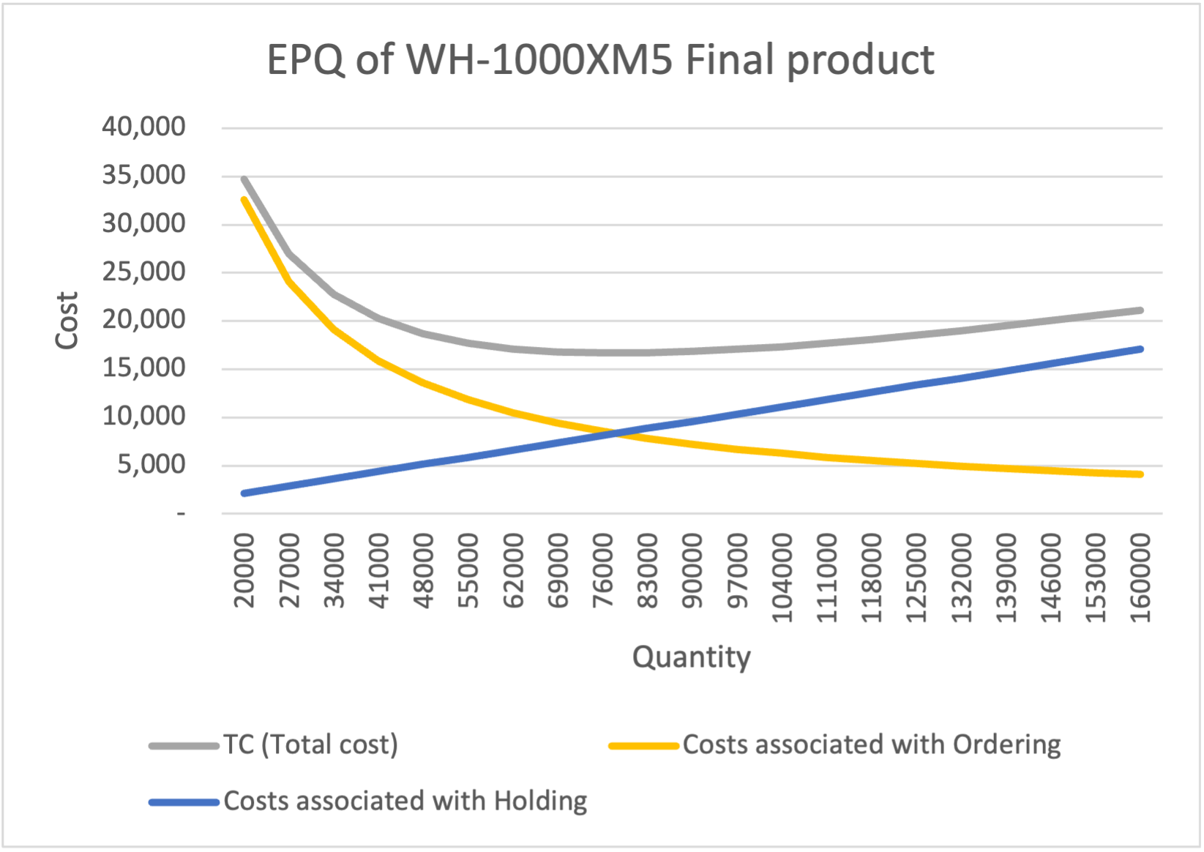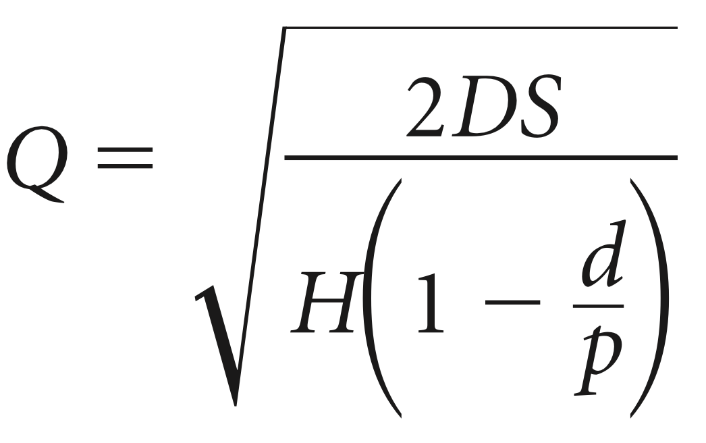

*Figure 29. Modelling of the EPQ of the final product. [source: team analysis]*

The same trend is seen as in EOQ, only the final quantity differs. Though the EOQ and EPQ models warrant enough to order quantities based on these numbers, sometimes quantity discounts are provided by suppliers, and taking that into account, it can get very complicated.

### **5.6 Discount Model**

We were assigned to test out the discount model with our purchases of just the charging circuit, and we assumed that higher order quantity leads to a decrease in the purchase price for each individual item cost. The discount for inventory management and price will depend on the number of units. The higher the number, the higher the discount, and the lower the final price will be. Because of this strategy, we can calculate the different variables needed to know what is the optimum strategy regarding inventory management.

Assuming the base price of the charging circuitry is $1.00, we have obtained the following discounts: 5% discount from 50K to 200K units, 8% discount from 200K to 300K units, and 10% discount above 300K. The cost projections as a function of units are visualized in figure 30.

As visualised in figure 30, ordering of 300K units is optimal to minimise total costs. However, the promotion plan is irregular in a way that the discounts provided represent a very significant decrease of the total cost, which implies that the price for more units is lower than the price for fewer units. This could be expected for the per unit price but not typically for the global price.

*Figure 30. Graphical representation of a discount model. [source: team analysis]*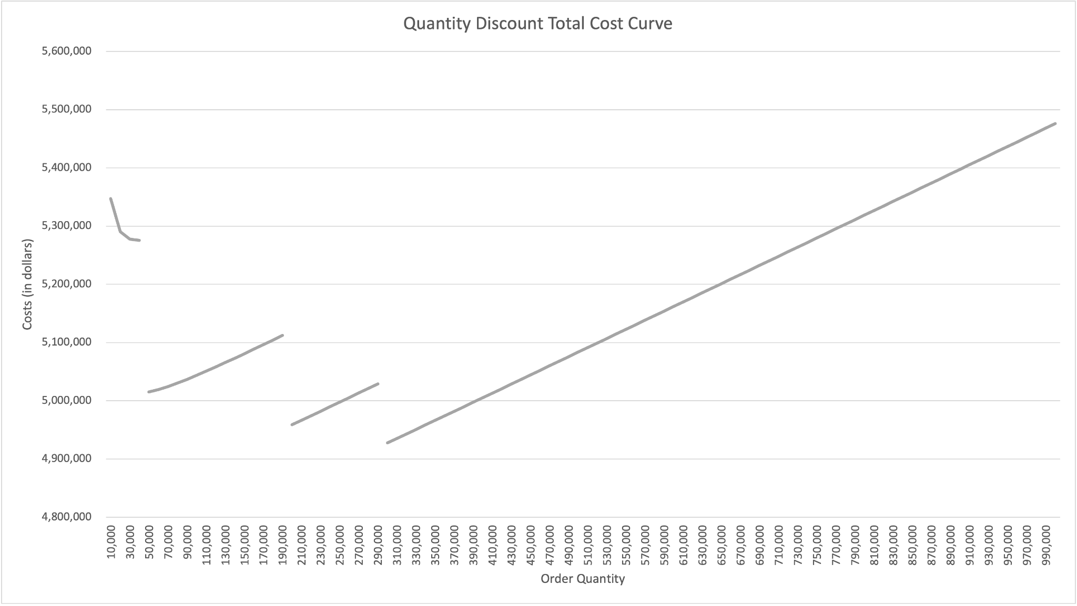

### **5.7 Inventory Management Models**

### **5.7.1 Safety stock model**

It is important to implement a safety stock as a security to meet unexpected customer demand. Increasing safety stock reduces the likelihood of shortages, resulting in a higher level of customer service. On the other hand, a larger safety stock is accompanied by higher holding costs or it can simply expire if the shelf life of goods is rather short. Therefore, it is crucial to determine the appropriate amount of safety stock required. To avoid possible shortages, the SS model is used as a tool to be prepared for unexpected customer behavior.

We decide on a safety stock model to ensure that we can accommodate unanticipated demands. The lead time, daily depletion rates, yearly holding costs, mean demand during lead time, and the standard deviation of the demand were all information obtained from previous sections.

We then assumed different service levels and calculated the safety stock (SS) and the reorder point (R) at each service level. To calculate SS, we multiplied the z-value, corresponding to the service level, with the standard deviation of the demand. The reorder point (R), therefore, can be calculated with the following equation:

$R=d·L+SS$

The reorder point (R) is calculated as the product of the mean demand during lead time and the lead time, plus the safety stock determined using the service level specified. This is how we determined the annual cost of purchasing at the reorder point. Annual Cost, SS value and Reorder point as the function of service level can be seen in Figure 31.

| Service level | **0,95** | **0,90** | **0,85** | **0,80** |
| --- | --- | --- | --- | --- |
| Number of standard deviation (z) | 1,64 | 1,28 | 1,04 | 0,84 |
| Safety Stock (SS) | 25.292 | 19.705 | 15.936 | 12.941 |
| Reorder Point (R) | 66,543 | 63,827 | 61,996 | 60,540 |
| Costs annually | 78,125 | 64,550 | 55,390 | 48,111 |

*Figure 31. Safety Stock model results depending on service level. [source: team analysis]*

### **5.7.2 Periodic review model**

To calculate the replenishment order quantity (R) some additional information is required. Like before, they are the standard deviation, the demand, and information about the order and inventory, such as the review period, service level, and lead time. Once we get these numbers, the Safety stock can be calculated using the following formulas and we can estimate the target stock, based on service level.

The target inventory (TI) level is calculated as:

$TI=d(RP+L)+SS$

Where:

TI = target inventory level in units

d = average period demand in units (period can be day, week, month, etc.)

RP = review period (in days, weeks, or months)

L = lead time (in days, weeks, or months)

SS = safety stock in units

The safety stock is calculated as:

$SS=zσ_{RP+L}$

Where:

z = number of standard deviations

$σ_{RP+L}$ = standard deviation of demand during review period and lead time and is calculated as:

$σ_{RP+L}=σ_{t}\sqrt{RP+L}$

Where:

$σ_{t}$ = standard deviation of demand during interval t

RP = review period

L = lead time

To calculate the replenishment order quantity, use the following formula:

$Q=TI-OH$

Where:

Q = replenishment order quantity

TI = target inventory level

OH = on-hand quantity

We assumed the periodic review is one week. Then:

$Total Demand= Daily demand rate · (lead time + review period)$

$Target inventory = Total Demand + SS$

It is evident that the higher service level necessitates a greater number of orders.

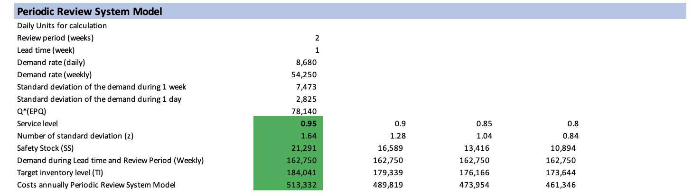

*Figure 32. Periodic Review System model results depending on service level. [source: team analysis]*

After calculating SS on different service levels, we can conclude that though Sony WH1000-MX5 is considered luxurious in terms of quality, it couldn’t allow itself to be absent in the store, cause the headphone is still a commodity good. Therefore, only a service level higher > 90% is acceptable for our product. In this essence, we would recommend selecting a service level of 95%.

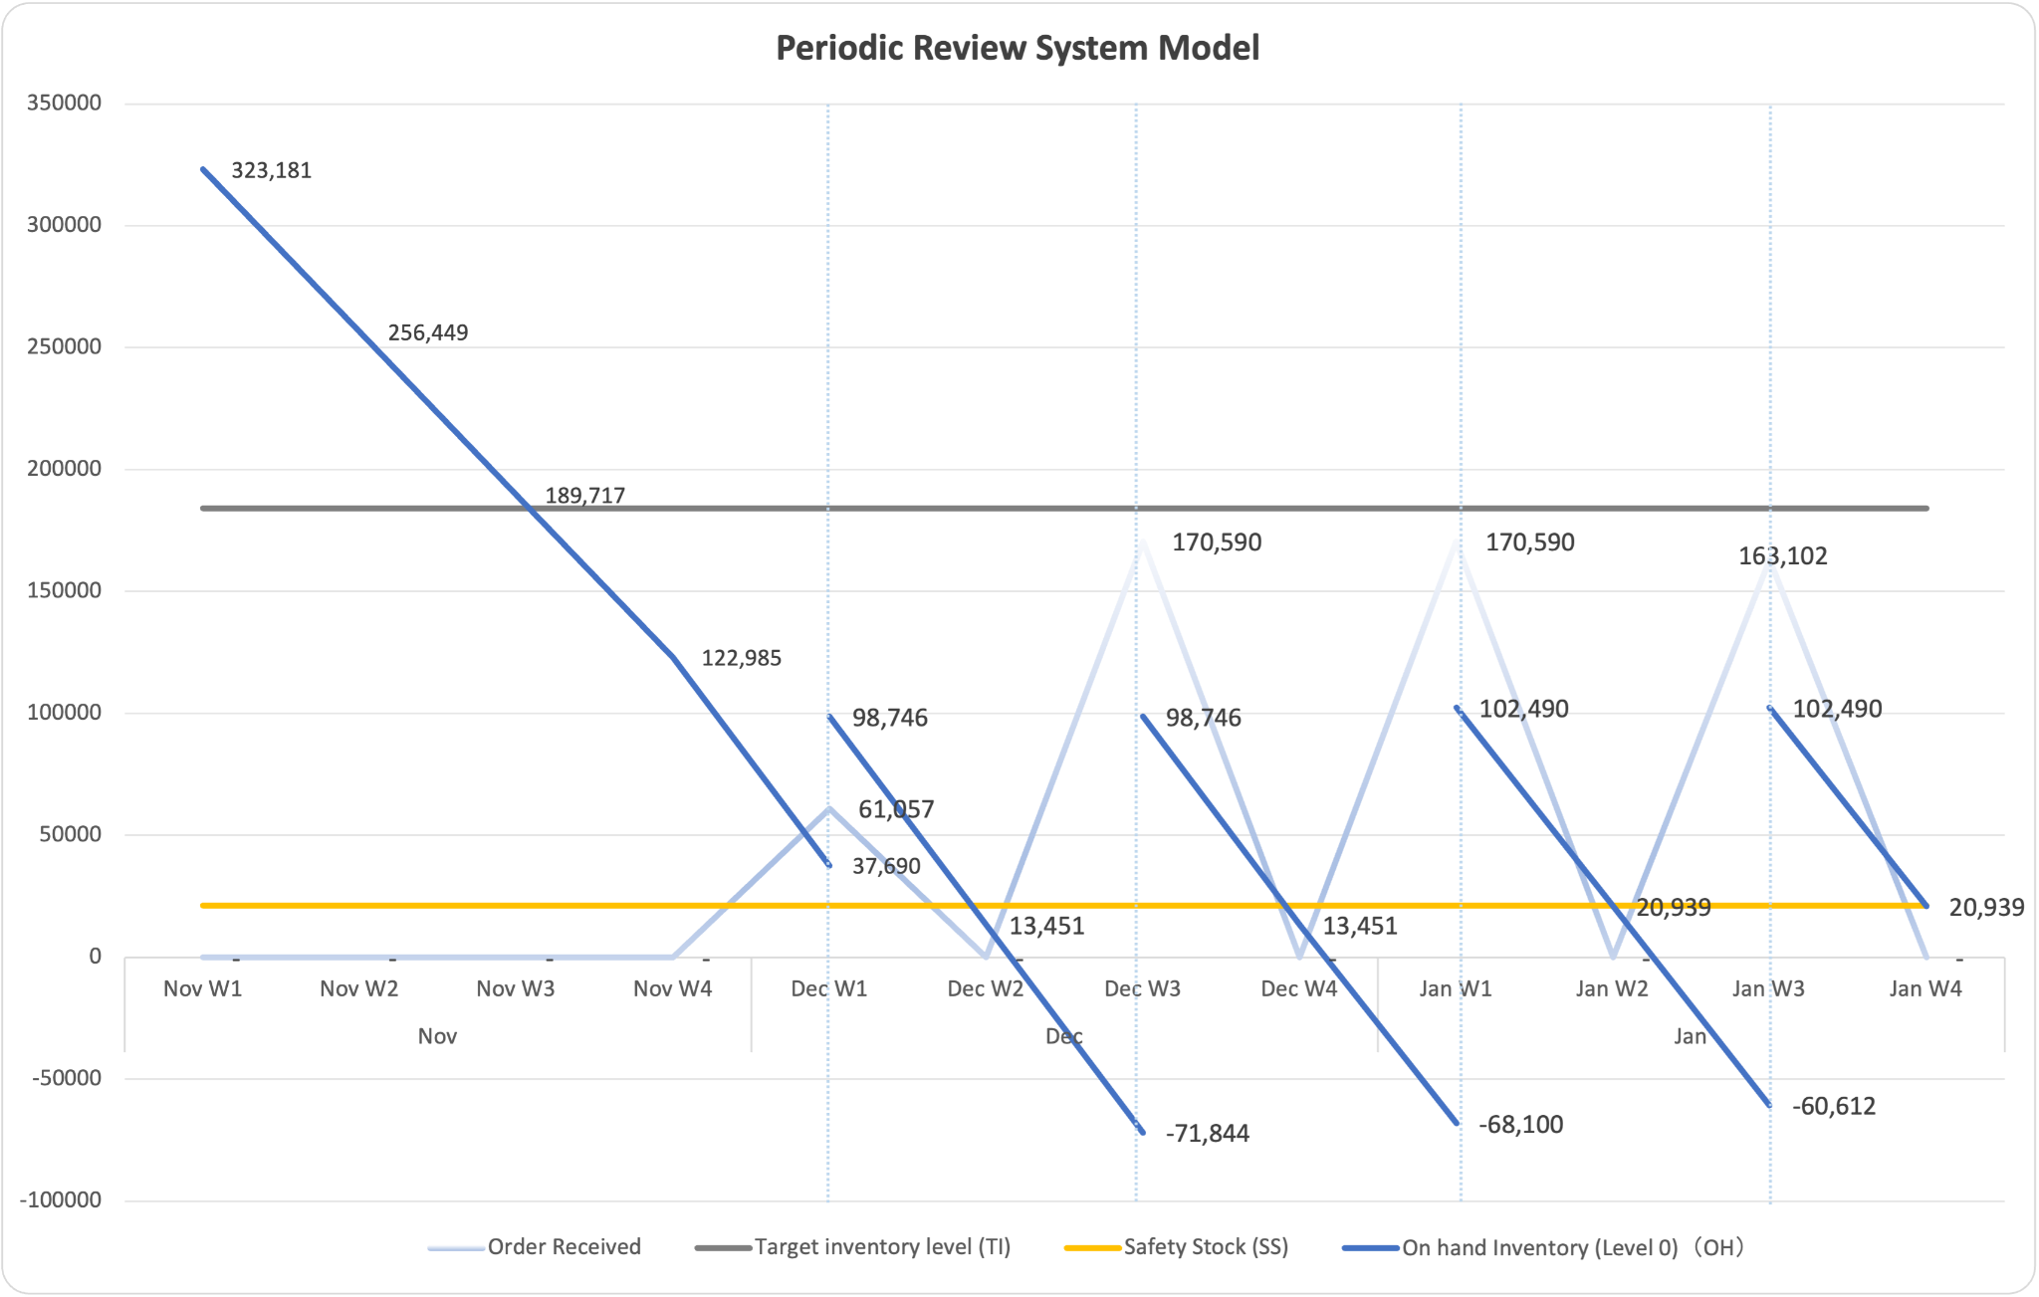

*Figure 33. Periodic Review System model results [source: team analysis]*

We know that in EPQ model, the Q* is 78’140 and the daily demand is 8680, so it is around 9 days to run out of Q*, We can make the following assumptions: Review time is 2 weeks, Leading time is 1 week, D: The annual demand, S: ordering cost, Q: we use the average order placed, H: holding cost. From the Graph and excel calculation, you can see the safety stock is 21’291, the Target Inventory level is 184’041. In fact, we never run below 0 inventory, though the graph might be misleading. The right most point of each segment of blue lines shows the current stock, without receiving orders.

### **5.7.3 Single Period inventory model (also known as Christmas model)**

In this model the optimal order quantity is calculated taking into account revenue, cost, salvage cost, alongside standard deviation and the optimal order. The assumption on revenue per unit, cost per unit, and salvage cost per unit remain constant by time, which leads to shortage and excess costs calculations, as well as the service level numbers.

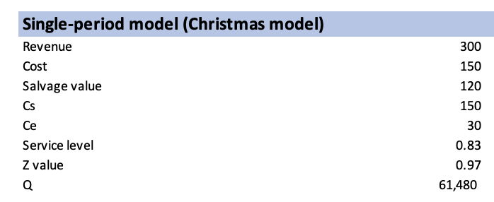

*Figure 34. Single-period model results. [source: team analysis]*

The Single Period Inventory Model does not make a lot of sense for our product - Sony Headphones as the service level of 83% is very low for Sony headphones. Furthermore, our product is not a perishable product and its value does not decrease significantly after a high peak of sales. Indeed, it has a peak of sales during Christmas but the sales remain high over the rest of the year. It is not necessary to propose any discount on the product. Furthermore, markdowns kill the luxury perceived value of the item (Sony WH1000-MX5 is luxurious headphones), which is why none of the luxury brands (LV, Hermes, etc.) conduct any promo events. Therefore, there is no need to conduct a mass promo or markdown event, while personalized promo for engaging high-income consumers and tech enthusiasts through personalized social media campaigns, to keep up with high perceived value with an exclusive release event.

## **6. Conclusions**

In summary, Sony’s success in the handphone industry is deeply connected to innovation, user-centered design, and a vertically integrated supply chain. It distinguishes itself by seamlessly integrating hardware and software to create a unique user experience. Our analysis shows, that, Sony is prepared to address moderately increasing consumer expectations and industry challenges with innovations while adhering to its mission of delivering exceptional value to its customers. One selected product, Sony headphones WH1000-MX5 was in the focus of this report. The production management of the WH1000-MX5 requires advance demand, supply, and inventory planning.

Demand planning consists of a forecast using the Holt and Winter model. The forecast predicts the New Year and Christmas peak, the first coming in December. The established forecast has a mean absolute percentage error of 3.98% on the validation set. The goal of the demand forecast is to manage production, supply, and inventory according to the predicted demand.

To obtain an overall idea of the production planning, aggregate plans are computed. The hybrid plan is selected as the best fit, because at $28.474 Million, it is only 15% more expensive than the cheapest plan, the level plan, which however doesn’t allow to tackle additional customer orders (high future missed sales) and has rather high outsourcing costs. What is more, it’s ethical compared to the chase plan. Afterward, a more detailed production plan with the Master production schedule is computed, and the dependent backward planning of children components from the BOM is calculated in the Material Requirement Planning.

Finally, different inventory planning models are established, from the Economic Order Quantity and Economic Production Quantity to the discount model, safety stock, periodic review model, and single inventory model. Taking the discounts on charging circuity into account, The MRP can be adapted to order 300 thousand units every 2 weeks, saving 10% in unit costs which more than makes up for the added inventory holding costs. Finally, the periodic review model is selected to be the best fit for the WH1000-MX5 headphones, with a weekly inventory review period of 9 days.

## **7. References**

[1] Sony Group Portal. (n.d.). *Sony Group history*. Retrieved from <<https://www.sony.com/en/SonyInfo/CorporateInfo/History/>>

[2] Sony Corporation. (n.d.). *Sony corporate website*. Retrieved from <<https://www.sony.net/>>

[3] Sony Corporation. (2024). *Sony responsible supply chain report 2024*. Retrieved from <<https://www.sony.com/en/SonyInfo/csr/library/reports/SustainabilityReport2023_sourcing_E.pdf>>

[4] Statista. (n.d.). *Sony sales worldwide by business segment*. Retrieved from <<https://www.statista.com/statistics/297533/sony-sales-worldwide-by-business-segment/>>

[5] Statista. (n.d.). *Key players in the headphones market*. Retrieved from <<https://www.statista.com/outlook/cmo/consumer-electronics/tv-radio-multimedia/headphones/worldwide#key-players>>

[6] Sony Corporation. (2024, May 5). *Sony news releases*. Retrieved from <<https://www.sony.com/en/SonyInfo/News/Press/202405/24-022E/>>

[7] Sony Corporation. (2024). *Sony corporation report 2024*. Retrieved from <<https://www.sony.com/en/SonyInfo/IR/library/corporatereport/CorporateReport2024/>>

[8] Ministry of the Environment Denmark. (2008). *Survey of chemical substances in headphones and hearing protection aids*. Retrieved from <<https://www2.mst.dk/udgiv/publications/2008/978-87-7052-733-0/html/kap07_eng.htm>>

[9] Bose, A. (2022). *How Sony's WH-1000XM5 outperforms its competition*. Tech Review Magazine. Retrieved from <<https://www.cnet.com/tech/mobile/bose-quietcomfort-ultra-headphones-review/>>

[10] Sony Corporation. (n.d.). *Sony WH-1000XM5 headband headphones*. Retrieved from <<https://www.sony.com.ph/electronics/headband-headphones/wh-1000xm5>>

[11] Sony Corporation. (2022). *Sony unveils new immersive listening experience with industry-leading noise-canceling WH-1000XM5 headphones*. Retrieved from <<https://www.sony.com/content/sony/en/en_us/SCA/company-news/press-releases/sony-electronics/2022/sony-electronics-unveils-new-immersive-listening-experience-with-newest-industryleading1-noise-canceling-wh1000xm5-headphones.html>>

[12] Sony Corporation. (n.d.). *User guide: WH-1000XM5 headphones*. Retrieved from <<https://helpguide.sony.net/mdr/wh1000xm5/v1/en/contents/TP1000536740.html>>

[13] Production Management / R. Glardon/ Chap 3, page 27 of 46

## **8. Disclosure of AI Tool Usage**

* OpenAI. (2024). *ChatGPT* (September 2024 version) [Large language model].
  + <https://chat.openai.com/share/66f57e4e-9214-800e-8daa-23486a67ac4d>
  + <https://chatgpt.com/share/66f5846e-49ac-8003-a340-54ce0dd62bf4>